THE RESPONSE OF TREE LEGUMES TO INOCULATION

WITH RHIZOBIA IN RELATION TO THEIR RHIZOBIAL SPECIFICITY

AND THE DENSITY OF INDIGENOUS RHIZOBIA

A THESIS SUBMITTED TO THE GRADUATE DIVISION
OF THE UNIVERSITY OF HAWAII IN PARTIAL FULFILLMENT
OF THE REQUIREMENTS FOR THE DEGREE OF

MASTER OF SCIENCE

IN

AGRONOMY AND SOIL SCIENCE

DECEMBER 1991

By

Robert Daniell Turk

Thesis Committee:

Paul W. Singleton, Chairman
Harold H. Keyser
Russell S. Yost
James H. Fownes

For my parents

Acknowledgements

I would like to thank all of the staff of the NifTAL project for assistance through all stages of work for this thesis. In particular, Kathy MacGlashan, Joe Rourke, and Patty Nakao helped considerably with the MPN assays; Geoff Haines and Kevin Keane helped prepare soils and shared the tedious task of picking nodules. Janice Thies provided lots of advice and encouragement.

I would like to express sincere gratitude to Harold Keyser, who served as my major advisor, for day to day guidance throughout.

Table of Contents

Acknowledgements................................... 3

List of Tables..................................... 5

List of Figures.................................... 7

Chapter 1. Thesis Introduction................... 8

Chapter 2. Comparison of Most-Probable-Number
Estimates of Tree Rhizobia with Plate
Counts................................ 11

Chapter 3. Rhizobial Specificity of Fast-Growing
Tree Legumes.......................... 30

Chapter 4. Response of Tree Legumes to Rhizobial
Inoculation in Relation to the
Population Density of Indigenous
Rhizobia.............................. 61

Chapter 5. Thesis Conclusion..................... 90

Appendix A. Generic Determination of Root Nodule
Bacteria.............................. 94

Appendix B. Data for Individual MPN Assays........ 96

Appendix C. Results of Effectiveness Tests........ 98

Literature Cited................................... 99

List of Tables

Table Page

2.1 MPN assays conducted with tree legumes....... 25

2.2 Seed sources, weight, and scarification and
surface sterilization methods................ 26

2.3 Strains used in MPN assays................... 27

2.4 Comparison of MPN estimates with plate counts
of tree legumes.............................. 28

3.1 Conflicting reports of rhizobial affinities
with tree legumes............................ 48

3.2 Plant combinations and time from inoculation
to harvest for each combination.............. 48

3.3 Strains used in pouch and pot experiments.... 49

3.4 Effectiveness of Rhizobium and Bradyrhizobium
strains on seven tree legumes................ 51

3.5 Comparison of species used in Pouch Experiment
B on the basis of rank correlation of shoot
dry weight and nodule numbers................ 52

3.6 Comparison of species used in Pouch Experiment
B with the same species used in pot
experiments by rank correlation of shoot dry
weight and nodule numbers.................... 53

3.7 Rhizobial specificity of tree legumes........ 53

4.1 Soils used in inoculation experiments and
MPN assays................................... 81

4.2 Strains used in inoculation experiments and
MPN assays................................... 82

4.3 Rhizobial densities of six tree legumes and
Macroptilium atropurpureum in four tropical
soils........................................ 83

4.4 Shoot dry weight response to mineral N....... 84

4.5 Models of shoot N response to inoculation
using measures of rhizobial density,
mineralized N, and BNF potential............. 85
List of Tables (continued)

Table Page

4.6 Effectiveness of indigenous vs. inoculant
rhizobial strains on Robinia pseudoacacia.... 86

List of Figures

Figure Page

2.1 Weekly assessment of MPN estimates........... 29

3.1 Nodule numbers and shoot dry weight of
Macroptilium atropurpureum and Acacia
auriculiformis in Pouch Experiment B......... 54

3.2 Nodule numbers and shoot dry weight of
Acacia mangium and Acacia mearnsii in Pouch
Experiment B................................. 55

3.3 Nodule numbers and shoot dry weight of
Albizia lebbeck and Lysiloma latisiliqua in
Pouch Experiment B........................... 56

3.4 Nodule numbers and shoot dry weight of
Paraserianthes falcataria in Pouch
Experiment B................................. 57

3.5 Cluster analysis of shoot dry weight and
nodule numbers of legumes in Pouch
Experiment B................................. 58

3.6 Shoot dry weight of Acacia auriculiformis
from a pot experiment........................ 59

3.7 Shoot dry weight and nodule numbers of
Acacia mangium and Acacia mearnsii from pot
experiments.................................. 60

4.1 Shoot N of six tree legumes and Macroptilium
atropurpureum grown in four soils with and
without inoculation.......................... 87

4.2 Shoot and root dry weight of six tree legumes
and Macroptilium atropurpureum grown in four
soils with and without inoculation........... 88

4.3 Nodule weight and numbers of six tree legumes
and Macroptilium atropurpureum grown in four
soils with and without inoculation........... 89

Chapter 1
Thesis Introduction
Nitrogen is the most limiting plant nutrient in agriculture (Singer and Munns, 1987). Despite its abundance, plants are unable to use N₂ directly. Most legumes, through symbiosis with rhizobia (in this thesis, rhizobia will be used to refer to both Rhizobium and Bradyrhizobium, unless specified differently), have the ability to reduce N₂ through biological nitrogen fixation (BNF) into a form usable for growth. Increasing demand for agricultural products combined with a need to conserve the world's limited resources make increased use of BNF in agriculture and forestry an important global objective. Fast-growing N₂ fixing leguminous trees are being widely promoted as sources of renewable energy and biologically fixed N for associated crops (Brewbaker et al., 1982; Dommergues 1987; Kang et al., 1984).
When appropriate rhizobia are absent from a soil, legume BNF does not occur. Then, inoculation of legumes with rhizobia can supply sufficient appropriate rhizobia to satisfy a plant's rhizobial requirements for maximal N₂ fixation and provide considerable return on investment in inoculant technology. However, where inoculant or needed infrastructure are not available, the cost of inoculant can be prohibitive. For farmers to determine if inoculation is a wise investment and for regional planners to decide if and where to develop needed associated infrastructure, it is important for both to be able to predict whether or not a response to inoculation will occur and the magnitude of the response.
Several approaches have been advanced for assessing the need for inoculation. Field experiments have the advantage of directly measuring the effect of inoculation on yield. However, results from field experiments are site specific and their cost generally precludes wide use.
Another approach, the focus of this thesis, is to use factors that determine response to inoculation as indicators of the magnitude of the response. Relationships between these factors and response to inoculation can be used to predict responses to inoculation in other areas. Experiments with grain and forage legumes have identified density of indigenous rhizobia as the major determinant of response to inoculation (Singleton and Tavares, 1986; Thies et al., 1991a and 1991b). Available soil N also influences the magnitude of response to inoculation (Thies et al., 1991b).
The use of rhizobial density for assessing the need to inoculate involves three key components: (i) use of the most-probable-number plant-infection (MPN) assay, (ii) a knowledge of rhizobial specificity, and (iii) establishment of the relationship between rhizobial density and response to inoculation. Because the accuracy of the MPN assay has not been established using trees and little is known about the rhizobial specificity of important tree legumes, these components will be addressed in Chapters 2 and 3 respectively. Chapter 4 examines the relationship between rhizobial density and response to inoculation of six tree species and the effect of available soil N on this relationship.

Chapter 2
Comparison of Most-Probable-Number Estimates of Tree
Rhizobia with Plate Counts

ABSTRACT
Enumeration of rhizobia by most probable number plant infection (MPN) assays has been conducted with only a few leguminous tree species as hosts. To see if reasonable agreement could be obtained using conventional plant infection growth systems, MPN estimates were compared with plate counts of pure cultures using seven tree species grown in both growth pouches and on agar slants in glass tubes and seven other species grown in growth pouches alone. Reasonable agreement can be obtained between plate counts and MPN estimates, with closer agreement in agar slants than growth pouches for small-seeded species. Agar slants and growth pouches should be scored for nodulation 5 and 7 weeks after inoculation, respectively.

INTRODUCTION
Although there has been significant interest in the potential of fast-growing nitrogen-fixing leguminous trees as fuelwood, fodder, construction material, and a source of biologically-fixed N₂ for associated crops in agroforestry systems, there has been little systematic study of their associated rhizobia. The most probable number plant-infection (MPN) assay, a technique widely used to enumerate populations of indigenous rhizobia, has only rarely been used with leguminous trees (Table 2.1). Rarer still are evaluations of its accuracy when used with trees. The purpose of this paper is to evaluate the accuracy of MPN assays with a variety of tree legumes grown in traditional growth systems through comparisons of plate counts and MPN estimates of the same pure rhizobial cultures.
The MPN assay is based on the capacity of rhizobia to form nodules on appropriate host plants under suitable conditions. MPN assays use the pattern of nodulated and non-nodulated plants inoculated with a dilution series to estimate the density of the rhizobial population in the original solution. Because no selective medium has proven reliable for distinguishing rhizobia from other microorganisms, the MPN assay is widely used for enumerating rhizobia in the presence of other microorganisms (Brockwell, 1980). Enumeration of indigenous rhizobia is especially useful for predicting the need to inoculate legumes with rhizobia (Brockwell et al., 1988; Thies et al., 1991b).
The agreement of plate counts with MPN estimates of pure rhizobial cultures provides a measure of compliance of the MPN assay with the underlying assumptions (see Scott and Porter, 1986) and a means for comparing the appropriateness of different growth systems for different legume species. An important assumption is that a single rhizobial cell causes nodule formation (Cochran, 1950). Although agreement between plate counts and MPN assays with pure cultures does not guarantee accuracy in the presence of other microorganisms, it is an essential step for establishing the reliability of the technique. While reasonable agreement has been obtained in some cases with grain and forage legumes, there is a tendency of MPN assays to underestimate plate counts (Scott and Porter, 1986). Boonkerd and Weaver (1982) reported underestimations greater than 100 fold.
It is important to keep in mind that plate count-MPN comparisons cannot be evaluated using conventional statistical approaches. The fiducial limits developed by Cochran (1950) were based solely on the dilution ratio and the number of replicate growth units per dilution level, given the assumptions of the assay. When the assumptions are not met, the actual fiducial limits will be higher than those calculated from theory (Scott and Porter, 1986).
A variety of growth systems have been used in MPN assays, including agar slants, tubes and cups filled with sand or horticultural vermiculite, Leonard jar assemblies (Leonard, 1944), and plastic growth pouches (Gibson, 1980). Agar slants have been recommended for legumes whose seeds are smaller than those of vetch (Vincent, 1970). Growth pouches are particularly useful for larger-seeded legumes.
No studies have investigated the number of weeks growth units need to be kept prior to scoring. Published reports of MPN assays conducted with tree legumes indicate that growth units have been kept for 3 to 12 weeks after inoculation before scoring (Table 2.1). It is unclear from these reports whether 3 or 4 weeks was sufficient for nodulation to occur or whether longer periods were essential.
The objectives of the experiments presented in this paper were to (i) evaluate the accuracy of the MPN assay for a variety of tree legumes; (ii) compare the suitability of growth pouches and agar slants for seven tree legumes; and (iii) determine how long the assay should continue.
MATERIALS AND METHODS
Growth systems
Two growth systems were used in this study. Acacia auriculiformis, Acacia mangium, Acacia mearnsii, Leucaena diversifolia, Paraserianthes falcataria, Robinia pseudoacacia, and Sesbania grandiflora were grown in plastic growth pouches (Northrup King Co.) and on agar slants in 25 mm x 250 mm glass tubes. Additional MPN assays were conducted in pouches with Albizia lebbeck, Albizia saman, Calliandra calothyrsus, Enterolobium cyclocarpum, Flemingia macrophylla, Gliricidia sepium, Leucaena leucocephala, and Sesbania sesban.
Agar slants were prepared according to Somasegaran and Hoben (1985) using 15 ml per tube of a plant nutrient solution containing 0.482 mM P, 0.96 mM K, 0.50 mM S, 0.21 mM Mg, and 0.29 mM Ca as K₂HPO₄, MgSO₄⋅7H₂O, and CaSO₄⋅2H₂O; 10 μmFe as FeEDTA; 0.0625 ml l⁻¹ of a micronutrient solution (Liquid Hawaiian Horticultural Mix, Monterey Chemical Co.); and 15 g agar l⁻¹. After autoclaving, the agar was slanted at an angle of 10° from the horizontal, producing a slant approximately 10 cm long, beginning at the base of the tube. The slant was designed to promote maximal contact between roots and rhizobia at the base of the slant and at the bottom of the tube. Growth pouches were prepared by filling each pouch with 50 ml of the same solution used in the tubes, minus the agar. An additional 50 ml of the same solution was added prior to inoculation. After inoculation pouches were provided with sterile water as needed until harvest.
Plant Culture and Selection
Seeds were scarified and surface sterilized with appropriate treatments (Table 2.2). After allowing the seeds to imbibe water for 5-12 hours, they were germinated on water-agar in petri plates according to Somasegaran and Hoben (1985). Two to 5 days later, when the radicles had reached 0.5 to 1.5 cm in length, the seedcoats of uniform seedlings were carefully removed to prevent hardening of the seed coat and to facilitate examination of tubes for nodulation. In tubes, seedlings were placed on the surface of the agar, with the root collar approximately 6 to 7 cm from the bottom of the slant. One and two seedlings were planted in tubes and pouches respectively. After planting, racks of pouches and tubes were placed in a growth room receiving > 300 μEinsteins m⁻² s⁻¹ of photosynthetically active radiation at plant height from 1000 W high pressure sodium lamps for 16 hours day⁻¹.
Prior to inoculation growth units with poorly growing plants were eliminated, leaving enough uniform plant growth units for at least 6 dilution levels with 4 replicate growth units each. In tubes, seedlings with tap roots that penetrated the agar were eliminated in accordance with the observation of Woomer et al. (1988b) that penetration of the agar by L. leucocephala roots resulted in poor nodulation. Of the trees grown in tubes for these experiments, A. mangium roots had the greatest tendency to penetrate the agar.
Inoculation
Rhizobial strains (Table 2.3) were grown for 6-10 days in either yeast-extract mannitol broth (Vincent, 1970) or arabinose-gluconate medium (Sadowsky et al., 1987). Prior to inoculation, cultures were diluted in a solution containing the salts found in yeast-extract mannitol broth (Vincent, 1970) with 0.01 % Tween 80 (Fisher Scientific Co.) added as a surfactant. Dilution procedures followed those outlined in Somasegaran and Hoben (1985). Either four-fold or 10-fold dilutions were used.
Seedlings were inoculated 7 to 12 days after planting, when root radicles reached the bottom of the slants or had begun to differentiate into secondary roots in pouches. One ml of diluted rhizobial culture was applied directly to the roots in pouches and to the lower portion of the roots in tubes. An average of seven uninoculated growth units were included per MPN assay as checks for contamination within the system. Uninoculated controls received 1 ml of rhizobia-free diluent.
Plate Counts
Plate counts were conducted at the time of inoculation using the Miles and Misra drop plate method as modified by Somasegaran and Hoben (1985). At least four replicate 0.03 ml aliquots were used from each of three dilution levels from the inoculation dilution series. Prior to data collection, plates were incubated at 27°C for 7 to 10 days for slow-growing strains, and 3 to 5 days for fast-growing strains.

MPN determinations
With two exceptions scored at 4 weeks, growth units of MPN assays were scored for nodulation 5 to 7 weeks after inoculation. The most probable number was determined using a computer program (Woomer et al., 1990), beginning with the highest dilution step in which all growth units nodulated.
Assessment of time to scoring
MPN assays in pouches and tubes of A. auriculiformis, A. mangium, A. mearnsii, and R. pseudoacacia, were scored weekly for nodulation from the second to the seventh week after inoculation. Weekly scores were also recorded for S. grandiflora and L. diversifolia, grown in pouches and tubes respectively.

RESULTS
The plate count was within the corresponding 95% confidence interval of the MPN (Cochran, 1950) for 18 of 54 plate count-MPN comparisons (Appendix B summarized in Table 2.4), indicating lack of a significant difference between them. However, in all but three plate count-MPN comparisons the MPN underestimated the plate count. The rhizobial density of the original solution ranged from 3.67 x 10⁷ to 7.55 x 10⁹ rhizobia ml⁻¹ as measured by the plate count. Over all MPN assays, only five of 384

uninoculated controls nodulated, with never more than one nodulated control per assay.
In tubes, all species with seed weights less than 25 mg seed⁻¹ (Table 2.1) had average plate count:MPN estimate (PC:MPN) ratios of less than 26. A. mearnsii, L. diversifolia, and P. falcataria in tubes and L. diversifolia, C. calothyrsus, and S. sesban in pouches all had average PC:MPN ratios less or equal to 2.1. S. grandiflora, with a seed weight of 36 mg/seed, had an average PC:MPN ratio of 1428.9 in tubes but only 5.8 in pouches. In pouches, seven of 14 species had average PC:MPN ratios of less than 35. For 11 of 14 tree species, PC:MPN ratios of less than 35 were obtained in either tubes or pouches.
Five of 10 MPN estimates from nodulation scores taken weekly from 2 to 7 weeks after inoculation increased after the fourth week (Figure 2.1). None of the 48 uninoculated controls nodulated in these assays. For species grown in both pouches and tubes, the average number of weeks to arrive at the final MPN estimate were 6.0 in tubes compared with 4.8 in pouches. In tubes, the MPN estimates of A. auriculiformis and A. mearnsii increased during the interval from 6 to 7 weeks after inoculation whereas in pouches, the MPN estimate of only one species, A. mangium, increased in the interval from 5 to 6 weeks and none after 6 weeks.

DISCUSSION
The excellent agreement between plate counts and MPN estimates observed with A. mearnsii, L. diversifolia, and P. falcataria in tubes and with L. diversifolia, C. calothyrsus, and S. sesban in pouches, indicates that relatively accurate measurement of rhizobial density can be achieved with pure cultures for a range of tree legumes. Tree legumes appear to be no different from herbaceous legumes in this respect. A high level of agreement between MPN estimates and plate counts (PC:MPN ratio < 6) has been obtained with many herbaceous legumes including clover (Brockwell, 1963; Tuzimura and Watanabe, 1961), alfalfa (Weaver and Frederick, 1972; Scott and Porter, 1986), chick pea (Toomsan et al., 1984), and soybean (Weaver and Frederick, 1972; Brockwell et al., 1975).
Growth pouches were not suitable for seven of 14 tree species and tubes not suitable for S. grandiflora. These species had PC:MPN ratios > 100, indicating that more than 100 rhizobia were required for nodule formation. Other authors have reported large discrepancies between plate counts and MPN estimates. Boonkerd and Weaver (1982) reported consistent underestimations involving Bradyrhizobium strains applied to cowpea and siratro. They obtained PC:MPN ratios of 260.6 for cowpea in pouches (mean of 4 strains), 255.0 for siratro in pouches (mean of five strains), 125.6 for siratro in vermiculite-filled cups (mean of two strains), and 15.3 for siratro in agar slants (mean of two strains). In our assays, of seven species grown in both pouches and tubes, good agreement of five species in only one of two growth systems suggests that the problems in obtaining agreement are growth-system related, rather than indicative of an inherent inability of trees to nodulate with a single rhizobial cell, as was suggested by Boonkerd and Weaver (1982) for cowpea and siratro.
Our results demonstrate the appropriateness of agar slants for small-seeded tree species and emphasize the need to tailor the growth system to the needs of the plant. Vincent (1970) reported that enclosed tubes were only appropriate for legumes with seed weight less than that of "vetch" (approximately 25 mg seed⁻¹). S. grandiflora, with a seed weight of 36.4 mg seed⁻¹, was the only species tried that did not grow well in tubes. Woomer et al. (1988b) noted the importance of placing the diluted inoculant directly on the roots of the plants to get good nodulation and noticed that the roots of Macroptilium atropurpureum tended to accumulate at the bottom of the tube without growing extensively on the surface of the slant where the inoculant was applied. Observations in our experiments confirmed that root growth of the Acacia spp. in particular was not extensive, especially in tubes, with most nodulation occurring at the bottom of the tubes. Therefore, the quantity of agar we used and the angle of the slant were designed to channel both roots and rhizobia directly to the bottom of the tube to ensure maximal contact between them. We found that 15 ml of agar was sufficient to support growth of the tree species we used for the duration of the assays.
Weekly assessment of MPN estimates (Figure 2.1) indicates the importance of keeping pouches for at least 5 weeks and tubes for at least 7 weeks after inoculation. Two to 3 weeks had been recommended as adequate by Vincent (1970), and 4 weeks by Brockwell (1980), based on MPN assays with herbaceous legumes. Scoring at 3 weeks had also been recommended as adequate for cowpea and siratro in pouches (Boonkerd and Weaver, 1982).
Reports of times to assessment of MPN assays with tree legumes (Table 2.1) indicate a range from 2-3 weeks to 11 weeks after inoculation, with nodulation in four of seven reports assessed at 3 weeks or less. The agreement Davis (1982) obtained between an MPN estimate and plate counts with L. leucocephala (PC:MPN ratio < 1) was from plants scored for nodulation approximately 11 weeks after inoculation.
In conclusion, our results indicate that reasonable agreement between plate counts and pure rhizobial cultures can be obtained with tree legumes but that results are very species and growth system dependent. MPN estimates using agar slants agreed well with plate counts for A. auriculiformis, A. mangium, A. mearnsii, L. diversifolia, P. falcataria, and R. pseudoacacia, while growth pouches gave acceptable agreement for C. calothyrsus, G. sepium, L. diversifolia, L. leucocephala, R. pseudoacacia, S. grandiflora, and S. sesban. Because of delayed nodulation, it is recommended that tubes and pouches be scored for nodulation at least 5 and 7 weeks after inoculation respectively. These results provide a basis for selecting appropriate growth systems for MPN assays with tree legumes and suggest that accurate MPN assays can be obtained in soils.

Chapter 3
Rhizobial Specificity of Fast-Growing Tree Legumes
ABSTRACT
Rhizobial specificity, defined in terms of nodulation and BNF effectiveness characteristics of a group of rhizobia on a host legume, has served as a basis for predicting the need to inoculate, selecting species for most-probable-number plant-infection assays, and preparing rhizobial inoculants suitable for a range of legume species. A series of cross-inoculation experiments were performed under growth room and greenhouse conditions to delineate rhizobial specificity of a variety of tree legumes. Gliricidia sepium, Calliandra calothyrsus, and Leucaena leucocephala nodulated effectively with rhizobia isolated from each of the three genera. With a few exceptions, Sesbania grandiflora and Robinia pseudoacacia nodulated effectively only with rhizobial strains isolated from each genus respectively. Considerable specificity was found among species that nodulate with Bradyrhizobium. While Acacia mearnsii nodulated with most strains but fixed N₂ effectively with relatively few, Acacia mangium and Lysiloma latisiliqua were specific for both nodulation and effectiveness.
INTRODUCTION
Nitrogen-fixing leguminous trees (NFLTs) are being planted on a wide scale in the tropics to provide fuelwood, construction materials, fodder, and nitrogen-rich biomass for improving soil fertility. Although biological nitrogen fixation is an important attribute of NFLTs, little has been done to delineate their rhizobial specificity in terms of nodulation and effectiveness.
Cross-inoculation is the reciprocal application of rhizobia isolated from different legumes to each other. A series of cross-inoculation experiments were conducted with a variety of tree legumes to delineate their rhizobial specificity in terms of nodulation and effectiveness.
Trees, in general, nodulate effectively and almost exclusively with either fast-growing rhizobia (genus Rhizobium) or slow growing-rhizobia (genus Bradyrhizobium) (Dreyfus et al., 1987). A few species nodulate effectively with some rhizobial strains from both genera such as Acacia seyal, Acacia sieberana (Dreyfus and Dommergues, 1987; Dreyfus et al., 1987), Acacia longifolia (Barnet et al., 1985), and Prosopis glandulosa (Jenkins et al., 1987). Tree species that nodulate effectively with fast-growing rhizobia are specific for nodulation and effectiveness (Duhoux and Dommergues, 1985; Gibson et al., 1982; Trinick, 1982) whereas species that nodulate with Bradyrhizobium are less specific (more promiscuous) for both characteristics (Graham and Hubbell, 1975; Date, 1977 and 1982). Trees that nodulate with Rhizobium have not been examined extensively for specificity for effectiveness with respect to each other. Similarly, specificity for effectiveness has not been systematically evaluated in tree species that nodulate with Bradyrhizobium. There is evidence that some non-woody legume species and cultivars that nodulate with Bradyrhizobium are specific for effectiveness and/or nodulation (Date and Norris, 1979; Burton, 1952; Keyser and Cregan, 1987, Thies et al., 1991c) and that A. mangium is specific for effectiveness (Galiana et al., 1990).
There is considerable confusion surrounding the generic classification of rhizobia that effectively nodulate some tree species (Table 3.1). Apparent misidentification of the genus of rhizobia that effectively nodulates some trees (eg. Calliandra and Gliricidia) is misleading given the view that species that nodulate effectively with Rhizobium are more likely to respond to inoculation than species that nodulate effectively with Bradyrhizobium (Dommergues, 1987; Dreyfus and Dommergues, 1981; Peoples et al., 1989).
The use of a small-seeded legume has been recommended for performing most-probable-number plant-infection (MPN) assays to determine the rhizobial population density of symbiotically related legumes (Vincent, 1970; Brockwell, 1980 and 1982). The only recommended substitution involving trees has been Desmanthus virgatus for Leucaena leucocephala (Brockwell, 1980 and 1982; Davis, 1982). Macroptilium atropurpureum has been recommended as a substitute for "cowpeas and symbiotically related species" (Brockwell, 1980 and 1982). Whether or not bradyrhizobial populations nodulating tree legumes can be enumerated accurately with M. atropurpureum has not been investigated.
Effectiveness groups of legumes are subsets of cross-inoculation groups that respond similarly to a set of rhizobial strains (Burton, 1979). They have served primarily as a guideline for inoculant preparation. Only four tree species have been ascribed to effectiveness groups: Leucaena leucocephala, L. retusa, Robinia pseudoacacia, and Albizia julibrissin (Burton, 1979; NiFTAL and FAO, 1984).
To delineate effectiveness groups of 14 tree legumes in terms of nodulation and effectiveness, two cross-inoculation experiments were performed in pouches. The purpose of the first experiment, termed Pouch Experiment A, was to evaluate fast-growing tree legumes using strains of both Rhizobium and Bradyrhizobium. The purpose of the second experiment, Pouch Experiment B, was to evaluate the specificity of a larger group of trees known to nodulate effectively with strains of Bradyrhizobium, using a larger number of these strains.
To confirm that data from the pouch experiments were not artifacts of the pouch system, effectiveness experiments were performed in pots in a greenhouse with three species, A. auriculiformis, A. mangium, and A. mearnsii. An additional objective of the pot experiments was to evaluate the effectiveness of a group of homologous strains (strains tested on the same species from which they were isolated) with A. auriculiformis and A. mearnsii.

MATERIALS AND METHODS
Tree species and rhizobial strains
Tree species (Table 3.2) were selected for their importance in reforestation and agroforestry in the tropics. Cultivars and seed sources are the same as described in Chapter 2 except for Lysiloma latisiliqua, obtained from Agroforestry Outreach Project, Haiti; Enterolobium cyclocarpum obtained from trees on Maui, Hawaii; and Vigna unguiculata cv. knuckle purple hull. Pouch experiment B evaluated seven tree species inoculated with 35 rhizobial strains. In pouch experiment B eight tree species were used that were either known to nodulate with bradyrhizobial strains from written reports (Allen and Allen, 1981) or from experience at the NifTAL project. M. atropurpureum and V. unguiculata were also included in Pouch Experiment B because they are recognized as nodulating effectively with a wide variety of bradyrhizobial strains (Vincent, 1970). Eight uninoculated pouches were included for each tree species.
Rhizobial strains (Table 3.3) were from the NiFTAL Project (1000 Holomua Ave., Paia, HI). As much as possible, in Pouch Experiment A at least three strains isolated from each tree species (or genus) were used. In Pouch Experiment B 34 Bradyrhizobium strains were used including NifTAL's recommended strains for cowpea (TAL 173, 209, 658), peanut (TAL 1000, 1371), and lima bean (TAL 22, 209, 658). The same set of strains was used on each species. Strains used in the pot experiments were a subset from Pouch Experiment B, including the best strains identified from each of the three Acacia species. In addition, all strains isolated from A. mearnsii and A. auriculiformis in the NiFTAL collection were used to inoculate their respective homologous hosts.
Growth systems and experimental design
Pouch experiments
In the pouch experiments, trees were grown in growth pouches (Northrup King Co.), with a single plant of each of two species grown in each pouch (Table 3.2). Pouches were prepared as described in Chapter 2. Growth room conditions were the same as used in Chapter 2.
Four replicates of each treatment were included in Pouch Experiment A, with six uninoculated controls per species. Six uninoculated controls were included per species in Pouch Experiment B. In Pouch Experiment A, pouches were not randomized but received uniform light. Other experiments in the growth room had not shown a significant differences across blocks (data not shown). For Pouch Experiment B, pouches were randomized in racks (Somasegaran and Hoben, 1985) in three blocks. Every two days racks were rotated around the table to ensure uniformity of light for all racks.
Pot experiments
In the pot experiments, plants were grown in 1 l plastic pots containing moistened horticultural vermiculite (Grace and Co.). Two, three, and four plants were grown per pot for A. mangium, A. mearnsii, and A. auriculiformis, respectively. A microtube irrigation system supplied nutrient solution daily. The nutrient solution was the same as used to fill the pouches except for the first 6 weeks with A. mangium when double strength solution was used. In addition, pots with A. mangium and A. mearnsii received 3 mM starter N in the nutrient solution in the form of CaNO₃ for the first 3 weeks after planting. Pots were covered with sterile gravel following inoculation to help prevent rhizobial contamination.

Each of the three pot experiments was set up in a randomized complete block design with three blocks for A. mangium and four for A. auriculiformis and A. mearnsii.
Seedling preparation and inoculation
Seeds for all experiments were scarified and surface sterilized as described in Chapter 2. Enterolobium cyclocarpum, and L. latisiliqua were scarified in the same manner as Albizia lebbeck. Seeds for the pouch experiments were germinated on water agar plates except for Albizia saman, A. lebbeck, and E. cyclocarpum, which were germinated in expanded vermiculite. All seedlings for the pot experiments were germinated in horticultural vermiculite (Grace and Co.) and transplanted into the pots 10 to 15 days later. For A. mangium and A. mearnsii, an extra seedling was transplanted into each pot; the least vigorous seedling was removed after 5 weeks.
Rhizobial strains were grown in yeast-extract mannitol (YEM) broth (Vincent, 1970) for 8 and 11 days respectively for Pouch Experiments A and B and for 8 days for the pot experiments. Plants were inoculated 8 to 16 days after planting in pouches, and within 24 hours after planting in pots. Pouches were inoculated by applying 1 ml of undiluted inoculant supplying approximately 10⁹ rhizobia ml⁻¹ in Pouch Experiment A and 1 ml of inoculant diluted 10-fold supplying approximately 10⁸ rhizobia ml⁻¹ in Pouch Experiment B to the roots of each plant. In pots, 1 ml of rhizobial broth culture containing approximately 10⁹ rhizobia ml⁻¹ was applied to each plant within 24 hours after planting and washed in with approximately 25 ml of sterile water.
Harvest and analysis
Plants were grown for various times before harvest to achieve maximal treatment differences (Table 3.2). At harvest plants in Pouch Experiment A were scored for effectiveness using a scale of 0 if no nodules formed on at least three of four replicates, "I" if plants nodulated but were not greener than uninoculated plants, "e" if at least two replicates were slightly greener than uninoculated plants, and "E" if at least two plants were greener and larger than "e" plants.
In Pouch Experiment B specificity for nodulation and effectiveness was assessed by single linkage cluster analysis of nodule numbers and shoot dry weight after standardization of values from zero to one. For shoot dry weight, uninoculated controls and treatments with values less than those of the uninoculated controls were given a value of zero. Specificity for nodulation and effectiveness was also assessed by rank correlation of nodule numbers and shoot dry weight respectively.
In the pot experiments, strains were evaluated using analysis of variance of log₁₀ transformed data except for shoot dry weight of A. auriculiformis where the data were not transformed because Bartlett's test showed that the variances were not significantly different at P = 0.05. Performance of strains used for the same species in Pouch Experiment B and in the corresponding pot experiment were compared by Spearman rank correlation.
Correlation and cluster analyses were carried out using the SYSTAT program (Wilkinson, 1990); the SAS program (SAS Institute, 1986) was used to perform analysis of variance with Tukey's HSD test in pouch experiment B the pot experiments.

RESULTS
Pouch Experiment A
In Pouch Experiment A, tree species that nodulated effectively with Rhizobium formed three distinct groups based on specificity for effectiveness while species that nodulated effectively with Bradyrhizobium formed a single group but still exibited a range of specificity for nodulation and effectiveness (Table 3.4). Leucaena leucocephala, Gliricidia sepium, and Calliandra calothyrsus consistently formed effective symbioses with rhizobia isolated from members of all three genera with some effective nodulation with strains from Sesbania species. Sesbania grandiflora and Robinia pseudoacacia only nodulated effectively with rhizobia isolated from their respective genera except for effective and moderately effective nodulation of S. grandiflora with a Calliandra strain (TAL 1801) and an Acacia mangium strain (TAL 1867) respectively and moderately effective nodulation of R. pseudoacacia with TAL 1145 and a strain from Calliandra (TAL 1455). R. pseudoacacia nodulated ineffectively with 19 of 35 strains, including both Rhizobium and Bradyrhizobium.
A. auriculiformis, A. mangium, A. mearnsii, Paraserianthes falcataria, and Tephrosia candida nodulated effectively only with Bradyrhizobium strains but revealed a range of specificity for nodulation and effectiveness. P. falcataria and T. candida formed effective symbioses with all Bradyrhizobium strains applied except TAL 102. At the other extreme, A. mangium failed to nodulate with five of 12 Bradyrhizobium strains and nodulated ineffectively with four of the remaining strains. All species that nodulated effectively with Bradyrhizobium strains nodulated ineffectively with some of the Rhizobium strains.
Pouch Experiment B
Distinct differences in the performance of different species were observed in Pouch Experiment B with respect to nodule numbers and shoot dry weight. Albizia saman, Enterolobium cyclocarpum, and Vigna unguiculata were not included in species comparisons due to lack of significant differences (P < 0.05) between the shoot dry weight of the uninoculated control and that of the best strain as evaluated by Tukey's HSD test. M. atropurpureum (Figure 3.1), A. auriculiformis (Figure 3.1), and A. lebbeck (Figure 3.3), had a higher proportion of relatively effective strains compared with A. mangium and A. mearnsii (Figure 3.2) as evaluated by shoot dry weight. L. latisiliqua (Figure 3.3) and P. falcataria (Figure 3.4) were intermediate between these groups. A. mangium (Figure 3.2) and L. latisiliqua (Figure 3.3) did not form nodules with three and four strains respectively. All other species nodulated with all 34 strains. The three strains that produced the highest shoot dry weight on A. mearnsii were all homologous, as was the best strain on A. mangium.
Single-linkage cluster analyses were used to summarize these relationships (Figure 3.2). With respect to nodulation, there were no differences discernable between M. atropurpureum, A. auriculiformis, and A. mearnsii. The other species were separated from this group by regularly increasing intervals, with A. mangium being furthest apart. Similarly, whereas A. mearnsii had significant rank correlation with M. atropurpureum and A. auriculiformis with respect to nodule numbers, nodulation of A. mangium was not significantly correlated with nodulation of any other species (Table 3.5).

In terms of shoot dry weight, A. auriculiformis, M. atropurpureum, A. lebbeck, and P. falcataria formed a group distinct from the other species (Figure 3.2). A. mearnsii was the only species whose shoot dry weights were not significantly correlated with shoot dry weights of M. atropurpureum by Spearman rank correlation (Table 3.4).
Pot Experiments
Nodulation and shoot dry weight response patterns observed in pouch experiment B were also evident in the pot experiments. The majority of strains were effective on A. auriculiformis in pots, with all but five of 27 producing significantly higher shoot dry weight than the uninoculated control (Figure 3.6). As in pouches, a large proportion of strains were relatively ineffective on both A. mangium and A. mearnsii (Figure 3.7). Correlation of shoot dry weight in the pot experiments with the dry weights from the same strains used in pouch experiment B yielded significant Spearman correlation coefficients (P< 0.05) for shoot dry weight and nodule numbers of A. mangium and A. mearnsii (Table 3.6).
The 10 strains with the highest dry weights for A. mearnsii in pots were all homologous isolates (Figure 3.7). Homologous isolates also were among the best strains for A. auriculiformis (Figure 3.6) and A. mangium (Figure 3.7) in the pot experiments.

DISCUSSION
Effective cross nodulation of G. sepium, C. calothyrsus, and L. leucocephala, by rhizobia from each of the three species but failure to nodulate effectively with most rhizobia isolated from other legumes, indicates that G. sepium, C. calothyrsus, and L. leucocephala belong to a common effectiveness group. Previously, L. leucocephala had been reported to nodulate with a strain isolated from C. calothyrsus (Halliday and Somasegaran, 1983) but without any information on effectiveness. Other researchers have reported effective nodulation of G. sepium (Somasegaran et al., 1989) and G. maculata (Akkasaeng et al., 1986) with fast-growing rhizobial strains. Our data conflict with unsubstantiated reports that G. sepium (Date, 1977; Dreyfus et al., 1987; Peoples et al., 1989; Trinick, 1982) and Calliandra (Peoples et al., 1989) nodulate with "cowpea," "slow-growing" or Bradyrhizobium strains.
The results from Pouch Experiment A support reports that S. grandiflora has highly specific rhizobial requirements (Abdel Magid et al., 1988; Johnson and Allen, 1952; Ndoye et al., 1990; Trinick, 1982). The data support reports of specificity for effectiveness of R. pseudoacacia (Allen and Allen, 1981; NifTAL and FAO, 1984). They indicate that R. pseudoacacia nodulates with a broad range of rhizobia in support of some reports (Burton, 1977; Crow et al., 1981; Wilson, 1944) but in disagreement with the conclusions of Allen and Allen (1981).
Based on the pattern of effective nodulation in Pouch Experiment A and on cluster analyses and rank correlation of shoot dry weight and nodule numbers in Pouch Experiment B, A. auriculiformis, A. lebbeck, P. falcataria, and T. candida appear to be promiscuous for both nodulation and effectiveness while A. mearnsii is promiscuous for nodulation but specific for effectiveness, and A. mangium and L. lysiliqua are specific for both nodulation and effectiveness. These data support the findings of Allen and Allen (1939) for A. lebbeck and of Galiana et al. (1990) for A. mangium, but are in disagreement with an unsubstantiated report that A. lebbeck is specific in its rhizobial requirements (Duhoux and Dommergues, 1985).
The results suggest that species-specific inoculants should be developed for S. grandiflora, R. pseudoacacia, A. mangium, A. mearnsii, and L. latisiliqua. A common inoculant could be developed for L. leucocephala, G. sepium, and C. calothyrsus, an expansion of the host range suggested by Somasegaran et al. (1989).
Similarly, a single inoculant could be developed for use with all species that are promiscuous for both nodulation and effectiveness. However, because no strains emerged as distinctly superior for all of the species in this category used in pouch experiment B and because a strain commonly recommended for inoculating grain and forage legumes in the cowpea miscellany, TAL 309 (CB 756), failed to nodulate A. auriculiformis effectively in pots, it would seem prudent to develop individual inoculants for each species. Another approach would be to develop a group inoculant consisting of a mixture of highly effective strains for each species rather than to rely on inoculant developed for use with other legumes that are promiscuous for both nodulation and effectiveness such as M. atropurpureum or Vigna unguiculata.
The data suggest that MPN assays conducted with L. leucocephala, G. sepium or C. calothyrsus should provide a reasonable approximation of the population of rhizobia present capable of nodulating the other two species. Similarly, M. atropurpureum will likely provide a reasonable estimate of the rhizobial densities of A. auriculiformis, A. mearnsii, A. lebbeck, P. falcataria, and T. candida, but not for A. mangium and L. latisiliqua
due to greater specificity of the latter species for nodulation.
In keeping with view that species that are more specific for effectiveness are more likely to respond to inoculation in the field than species with less specific rhizobial requirements (Dommergues, 1987), L. leucocephala, G. sepium, C. calothyrsus, A. mearnsii, A. mangium, and L. latisiliqua should be more likely to respond to inoculation than A. auriculiformis, A. lebbeck, P. falcataria, or T. candida.
In summary, the trees studied in the experiments described here can be categorized based on effective nodulation with Rhizobium or Bradyrhizobium and specificity for nodulation and effectiveness (Table 3.7).

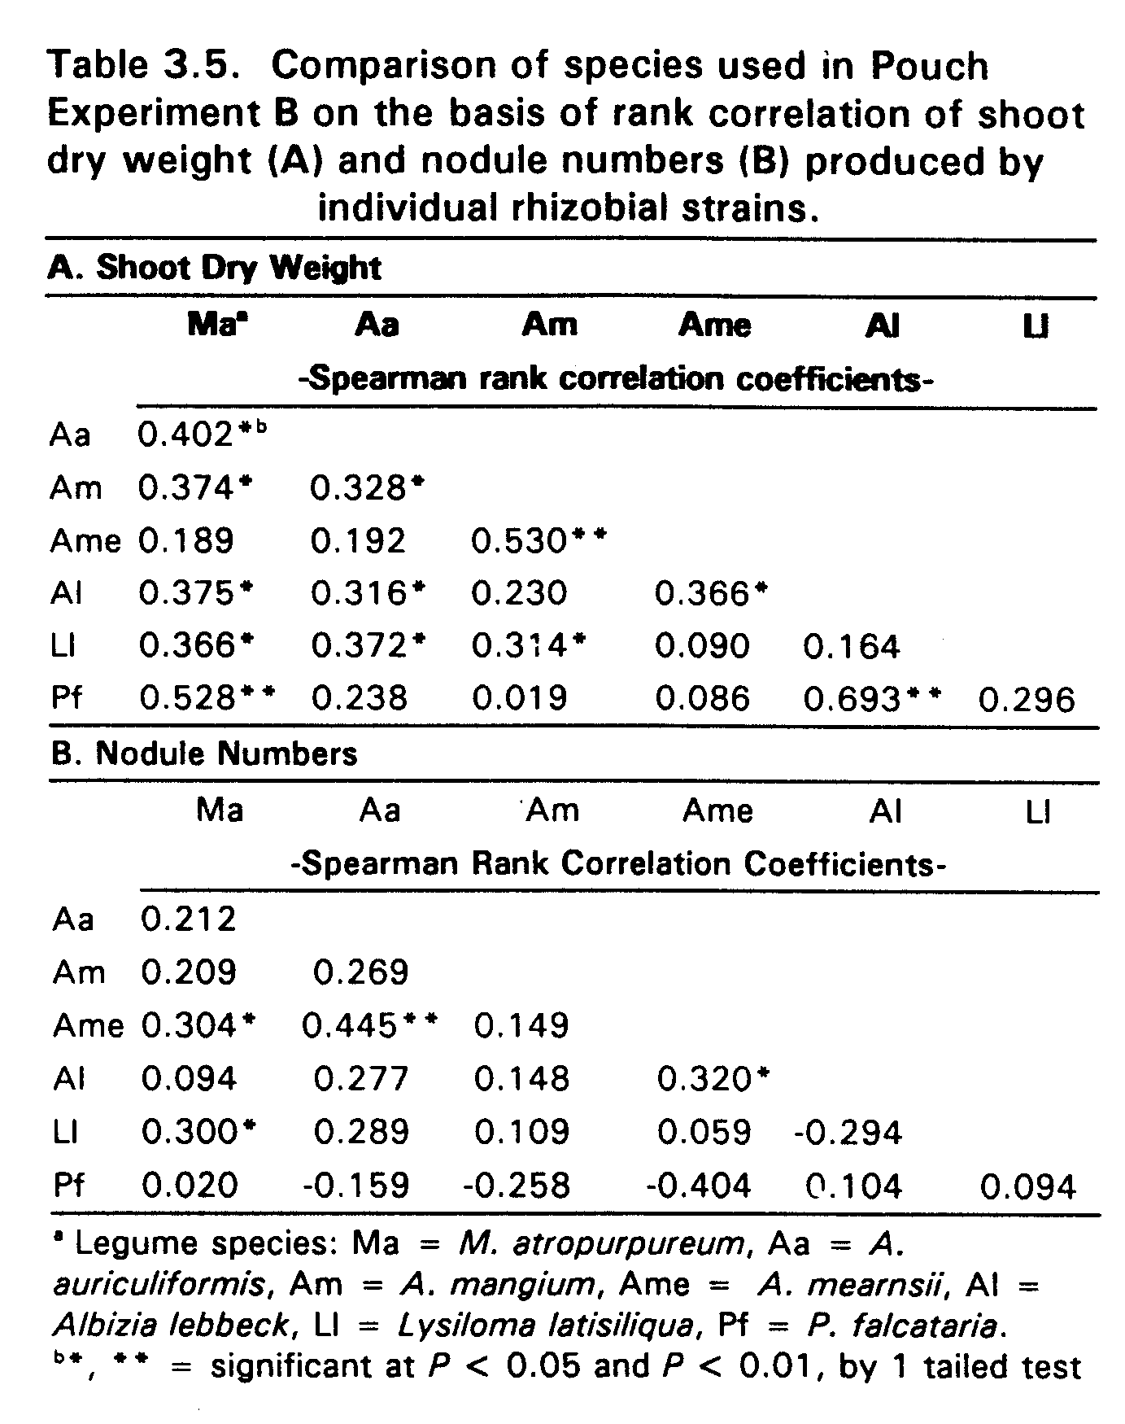

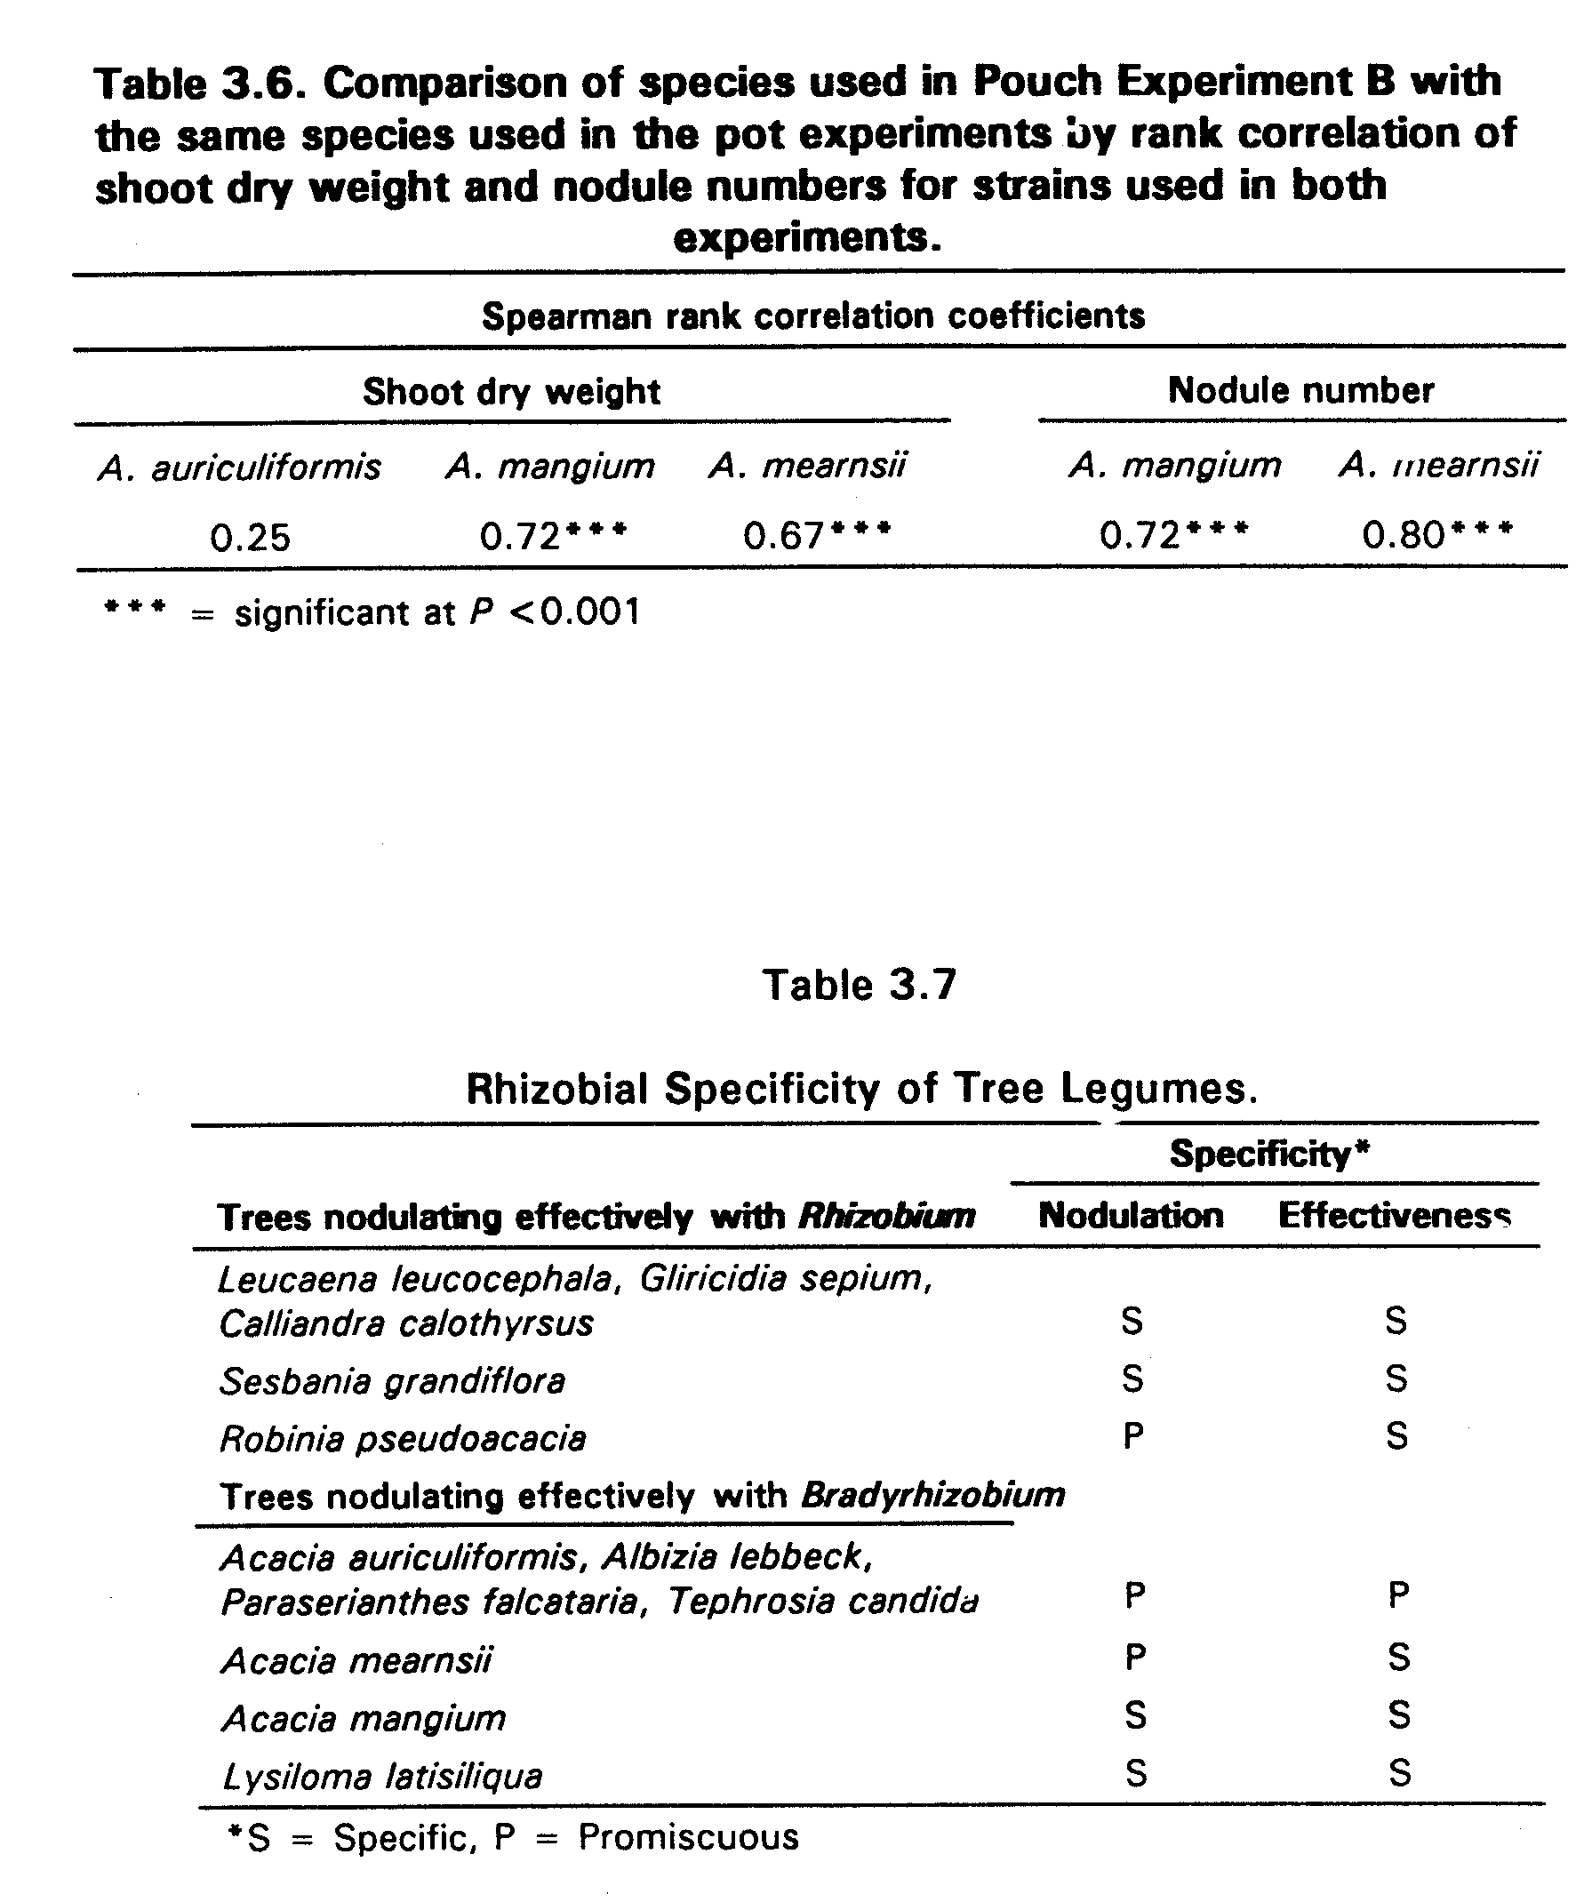

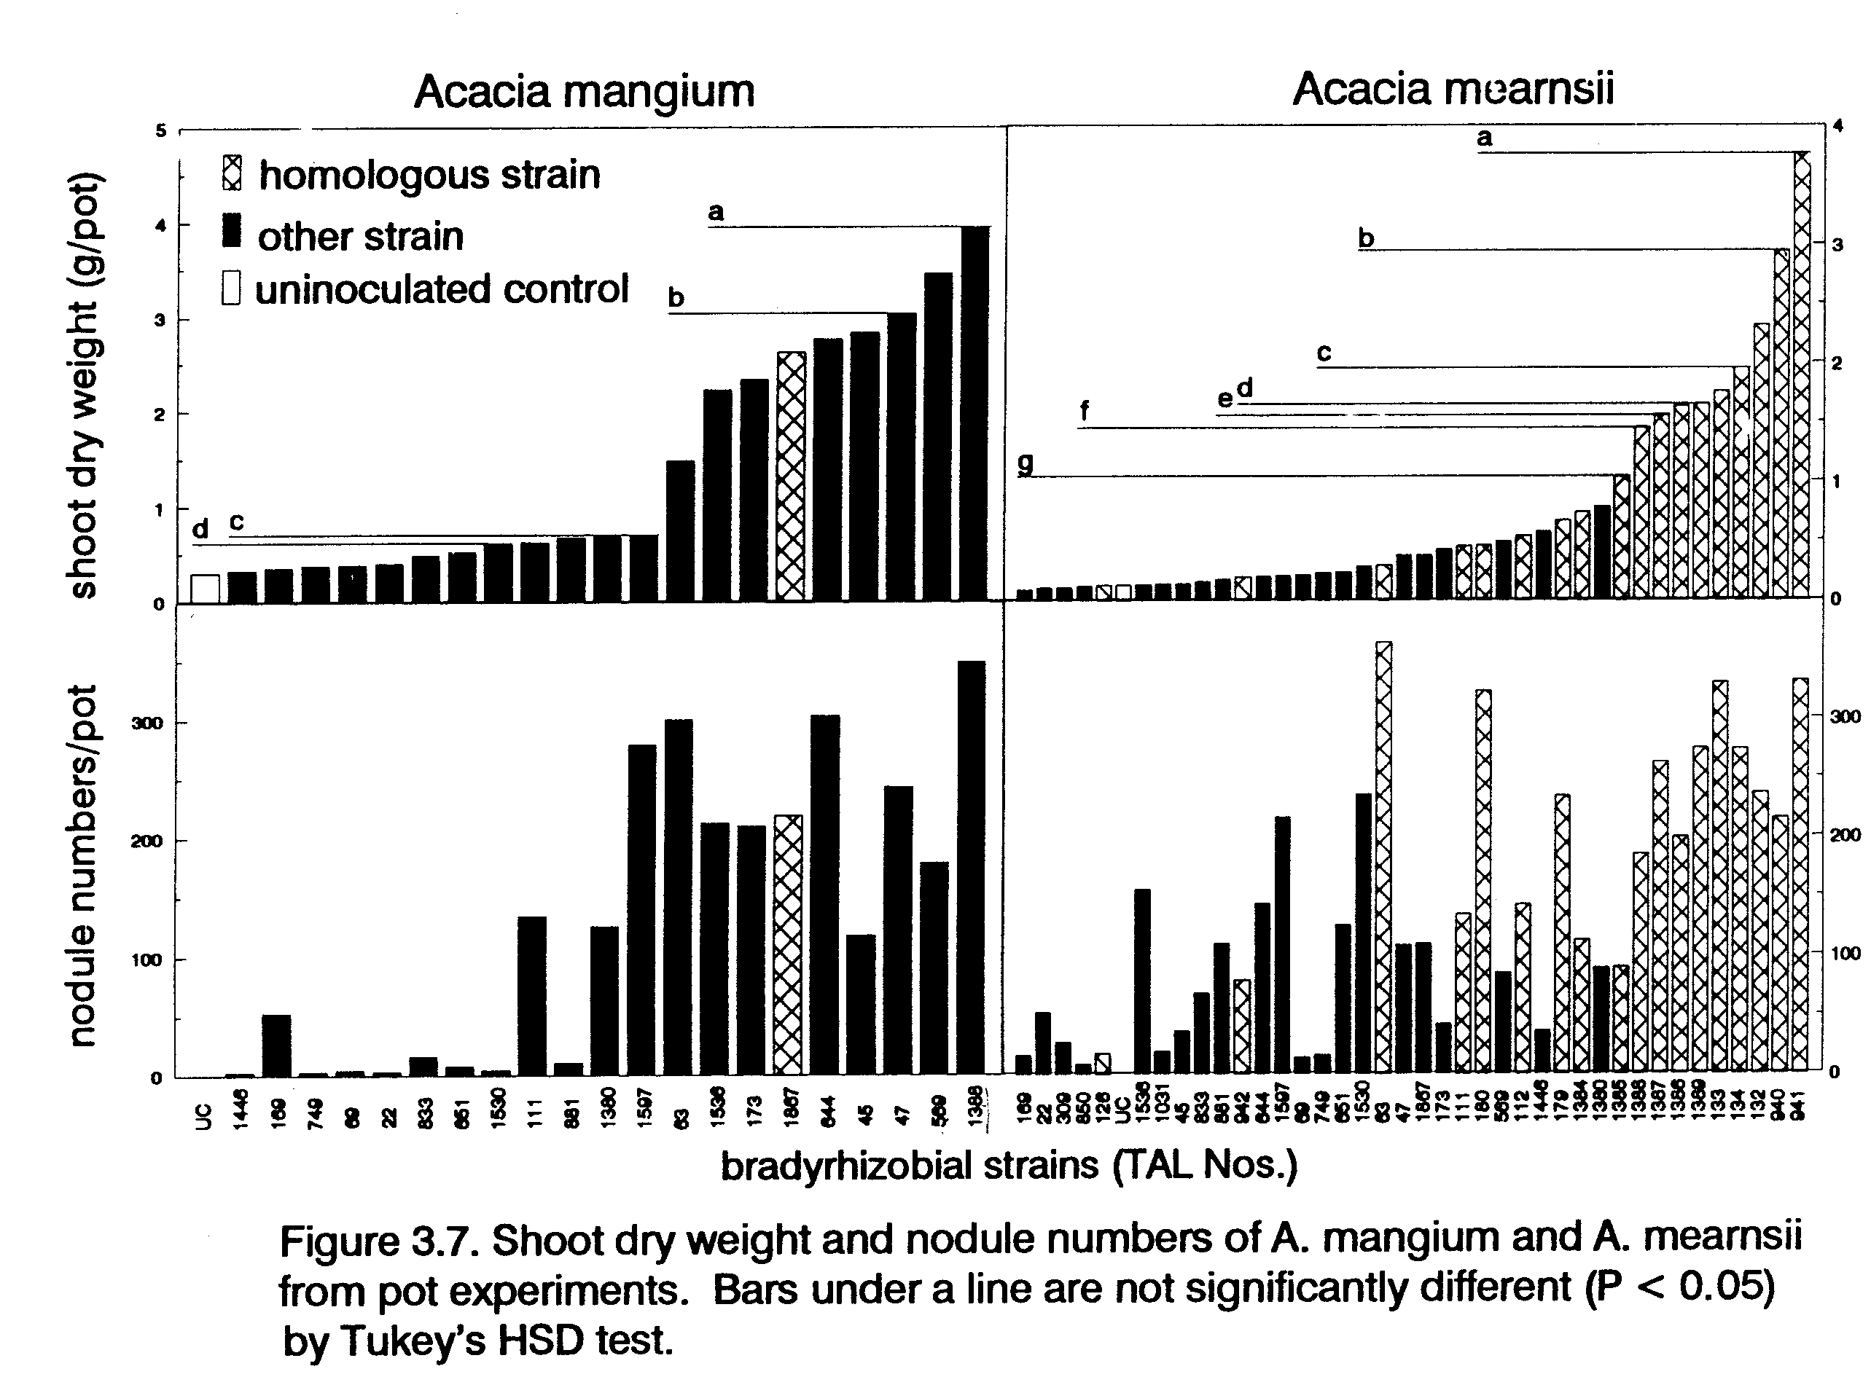
Chapter 4
Response of Tree Legumes to Rhizobial Inoculation
in Relation to the Population Density
of Indigenous Rhizobia
ABSTRACT
To determine the relationship between yield response to inoculation and rhizobial population density for leguminous trees, inoculation experiments were conducted in pots containing four soils in a greenhouse on the island of Maui, Hawaii, with Acacia auriculiformis, A. mangium, A. mearnsii, Leucaena diversifolia, Robinia pseudoacacia, and Sesbania grandiflora. Densities of indigenous rhizobia were determined by most-probable-number plant-infection assays. Response to inoculation was calculated for each species-soil combination as the increase in shoot nitrogen due to inoculation. The magnitude of the response was inversely related to the density of rhizobia in the soil, with the greatest responses where rhizobial densities were less than 50 rhizobia g⁻¹ soil. Tree species known to nodulate effectively with Rhizobium had a higher proportion of significant responses to inoculation than species known to nodulate effectively with Bradyrhizobium. R. pseudoacacia and A. mearnsii responded significantly (P < 0.05) to inoculation in three and one soils respectively despite the presence of more than 1000 rhizobia g⁻¹ soil. A hyperbolic model best described the relationship of the increase in shoot dry weight due to rhizobial inoculation to the density of indigenous rhizobia. Incorporation of an index of available soil N into this model resulted in models with lower residual mean square values, indicating the important role of mineral N in mediating responses to rhizobial inoculation.

INTRODUCTION
As natural forests are depleted and fallow periods diminished in shifting agricultural systems of the tropics, fast-growing nitrogen-fixing trees are becoming more important as sources of fuelwood, fodder, and nitrogen-rich biomass. Inoculation of tree seeds or seedlings with rhizobia can insure that enough highly effective rhizobia are present to satisfy the trees' demand for biological nitrogen fixation (BNF). Where available mineral N limits growth and appropriate indigenous rhizobia are scarce or absent, inoculation can increase yields and and monetary returns. However, infrastructure and educational constraints often prevent farmer use of rhizobial inoculant in the tropics. Because of the expense involved in overcoming these constraints, knowledge of if, and how much, inoculation is likely to increase yields can help farmers and regional planners make sound decisions concerning investment in rhizobial inoculant technology. In this paper, a method is evaluated for predicting the magnitude of response to inoculation for six tree legumes based on the density of indigenous rhizobia.
The quantification of factors regulating the response of legumes to inoculation has been proposed as an approach for assessing the magnitude of responses to inoculation with rhizobia without resorting to pot or field experiments (Singleton and Tavares, 1986; Brockwell et al., 1988). Major factors likely to influence response to inoculation are (i) limitations to plant growth other than N; (ii) density of indigenous rhizobia in soil; (iii) effectiveness of indigenous rhizobia; and (iv) available mineral N (Singleton et al., 1991a). A major advantage of this approach is that it permits extrapolation of results beyond the fields where soils were tested.
Models of the response to inoculation of field-grown grain and forage legumes (Thies, 1991b) indicated that when limitations other than N are removed, rhizobial density as estimated by the MPN assay is the primary factor determining the magnitude of response to inoculation. Models that accounted for the effects of mineral N availability in addition to rhizobial density improved the agreement between observed and predicted inoculation responses. Singleton et al. (1991a) noted that measures of indigenous rhizobial population effectiveness have not proven to be good indicators of the magnitude of response to inoculation.
This study was conducted to determine the relationship of shoot N response to rhizobial inoculation of six tree legumes to an index of available mineral N and to the density of their indigenous rhizobial populations. A second purpose was to evaluate how specificity for nodulation and effectiveness of tree legumes (Chapter 3) relate to patterns of indigenous rhizobial densities and responses to inoculation.

MATERIALS AND METHODS
General Experimental Approach
Pot experiments were conducted in a greenhouse at 110 m elevation at Hamakuapoko, Maui, Hawaii. Four soils (Table 4.1) were selected, two with total indigenous rhizobial densities greater than 10 000 rhizobia g⁻¹ soil, and two with rhizobial densities less than 200 rhizobia g⁻¹ soil, as determined by MPN counts on five legumes representing the cross-inoculation groups of the legumes growing at the sites (Woomer et al., 1989a). Leucaena leucocephala was growing at one low rhizobial density site and at one high density site. Tree species were selected on the basis of rhizobial specificity as determined in Chapter 3. Three species known to nodulate with Rhizobium, Leucaena diversifolia, Robinia pseudoacacia, and Sesbania grandiflora, were from genera determined in Chapter 3 to belong to distinct effectiveness groups. The three species chosen that nodulate effectively with Bradyrhizobium, Acacia auriculiformis, A. mangium, and A. mearnsii, showed a range of specificity for effectiveness and infectiveness (Chapter 3).
Seed sources were the same as indicated in Chapter 2. Macroptilium atropurpureum cv. siratro, a herbaceous forage legume which nodulates effectively with many Bradyrhizobium (Vincent, 1970) was included for comparison with the Acacia spp. Treatments were (i) inoculation with rhizobia and (ii) no inoculation. Two species in each soil received mineral N to measure yield potential in the growth system. The experiment was divided into two. The trials in Pane and Makawao soils were conducted from 7 December 1990 to 8 February 1991 and in Keahua and Waiakoa soils from 1 February 1991 to 5 April 1991. Pots were arranged in a randomized complete block design, with four replicates. Results were analysed using SYSTAT, version 5.0 (Wilkinson, 1990), by dependent one-tailed t tests for each species-soil combination.
Soil Collection and Plant Culture
At each soil collection site the soil was excavated to a depth of 20 cm and passed through a screen with a 5 mm opening. Five-liter black plastic pots lined with polyethylene bags were filled with 2000, 3300, 3500, and 4520 g of soil (dry weight basis) per pot for Pane, Makawao, Keahua, and Waiakoa soils respectively. These weights produced approximately equivalent volumes of each soil. The following fertilizers were added (Kg⁻¹ soil): 1.07 g K₂HPO₄, 0.25 g MgSO₄⋅7H₂O, and 0.5 ml kg⁻¹ of a liquid micronutrient mix (Hawaiian horticultural mix, Monterey Chemical Co.). A total of 450 mg of N Kg⁻¹ soil as ammonium nitrate was added to the mineral nitrogen controls at three intervals: 50 mg kg⁻¹ soil at the time of inoculation, 150 mg kg⁻¹ soil 3 weeks after inoculation, and 150 mg kg⁻¹ soil 6 weeks after inoculation.
Tree seeds were scarified and surface sterilized as described in Chapter 2. M. atropurpureum seeds were treated in the same manner as L. diversifolia, except exposure to concentrated sulfuric acid was limited to 8 minutes. Imbibed seeds were planted in trays containing expanded horticultural vermiculite (Grace and Co.) 4 to 10 days prior to transplanting into the pots. Four to eight seedlings were planted per pot and thinned to four plants per pot after 3 weeks. Following inoculation, the surface of each pot was covered with 850 g of sterile washed road gravel to guard against rhizobial contamination. Pots with M. atropurpureum were provided with sterile stakes because they have a climbing growth habit. Pots were watered to field capacity every 3-4 days as required throughout the course of the experiment.
Inoculation and Harvest
The inoculant consisted of a three strain mixture of appropriate strains for each species (Table 4.2). Each strain was grown separately for 6 to 10 days in either yeast-extract manitol (YEM) broth (Vincent, 1970) for the first two soils or in arabinose-gluconate medium (Sadowsky et al., 1987) for the second two soils. Within 2 days after planting, each pot received 5 ml of a 10⁻³ dilution of the appropriate three-strain mixture. The inoculum was applied evenly around the roots of each seedling to give approximately 5 x 10⁶ rhizobia per pot, an inoculation rate within recommended rates. The inoculant was washed into the soil with 50 ml of sterile water.
Plants were harvested 9 weeks after inoculation. Tops were severed at gravel level, dried at 70°C, weighed, ground, and analysed for N content using a Leco 600 C-H-N analyser. The root systems of three replicates were cleaned by washing over 1 mm mesh screens. Nodules were removed and counted, and both roots and nodules weighed after drying at 70°C.
Soil N Availability
N mineralization values for each soil were determined following the anaerobic incubation method of Keeney (1982). A standard curve was used to determine the amount of NH₄⁺ present after distillation to avoid the need to standardize H₂SO₄. N mineralization values were multiplied by the dry weight of soil per pot and the number of weeks the plants were grown to yield an index of N mineralized per pot over the course of the experiment. Demand for symbiotic N was assessed by calculating the percent N derived from fixation (%NDF) of S. grandiflora in each soil. For each soil, %NDF was calculated as:

(N_{SI} - N_{SU})
%NDF = --------- x 100
N_{SI}

where N_{SI} = average total shoot N of S. grandiflora in inoculated pots, and N_{SU} = average shoot N of S. grandiflora in uninoculated pots. The few nodules produced by S. grandiflora in uninoculated pots were completely white in cross-section except for a single plant in Pane soil. Shoot dry weight from this pot was not used for the calculation of %NDF.
MPN assays
MPN assays for each species-soil combination were conducted using the best growth system identified for each species in Chapter 2. For each of the two sets of greenhouse experiments, plate counts and MPN assays of pure rhizobial cultures (Table 4.2) were compared as described in Chapter 2 to provide an evaluation of the growth systems used, in accordance with the

recommendations of Thompson and Vincent, 1967; Scott and Porter, 1986; and Singleton et al., 1991b.
Soil for the MPN assays were taken just prior to planting from extra pots used in the pot experiment. Fifty g of soil (dry weight equivalent) was used for the initial dilutions. Dilution ratios were 4.0 for L. diversifolia, R. pseudoacacia, and S. grandiflora in Pane and Makawao soils and 5.0 for all other species-by-soil combinations. The amount of soil applied at the lowest dilution level was 1 g for Pane and Makawao soils, and 0.2 g for the other two soils. Eight uninoculated controls were interspersed among the growth units of each MPN assay.
Nodulation was assessed at 7 weeks after inoculation. The most-probable-number was determined with a computer program (Woomer et al., 1990), using as initial dilution the highest dilution in which all four replicates nodulated or, in the case of A. mearnsii in Makawao soil where no dilution level had four nodulated growth units, the third from last dilution level.
Models of Response to Inoculation
Models relating the response to inoculation to the density of indigenous rhizobia were fit to the data using a variety of functions with the 'nonlin' module of the SYSTAT program version 5.0 (Wilkinson, 1990). Response to
inoculation for each species-soil combination was defined as

(N_{SI} - N_{SU})
R = --------- x 100
N_{SU}

where R = response to inoculation and N_{SI} and N_{SU} are as described for %NDF.
The indices of available mineral N and symbiotic N demand were incorporated into a mathematical equation to model the effect of mineral N and symbiotic N demand on the relationship of rhizobial density to response to inoculation. The model used was:
a
y = -----
1+MPN

where y is shoot N increase due to inoculation expressed as a percentage of the shoot N of plants in uninoculated pots, a is the y-intercept, and x = 1 plus the density of the indigenous rhizobial population, expressed as the number of rhizobia g⁻¹ soil on a dry weight basis. Linear, exponential, power, and hyperbolic functions of mineralized N and %NDF were incorporated into this model through replacement of the y-intercept.
Rhizobial Isolation and Effectiveness Tests
Rhizobia were isolated from at least 20 nodules of R. pseudoacacia in both Makawao and Pane soils. These rhizobia were selected for characterization because the response of R. pseudoacacia in these two soils despite the presence of over 20 000 rhizobia g⁻¹ soil suggested that the rhizobia were ineffective at fixing N₂. Random nodules from extra uninoculated pots were used for isolating the rhizobia. Rhizobia from each nodule were isolated, authenticated, and their pH reactions on bromothymol blue determined following methods described in Somasegaran and Hoben (1985).
Isolates from R. pseudoacacia from the two soils were inoculated onto agar slants containing legumes in the effectiveness groups of legume species nodulating with Rhizobium found growing at each soil collection site. The purpose was to determine the natural host(s) of the rhizobia that nodulated R. pseudoacacia from among the legumes growing at each site. The species used were: Trifolium repens, Vicia sp., and Medicago sativa in Pane soil and T. repens and L. diversifolia in Makawao soil.
An effectiveness test was conducted with 20 isolates from each soil. Isolates from each soil were grown for 7 days in YMB, mixed, and inoculated onto R. pseudoacacia in growth pouches (two plants/pouch) prepared as described in Chapter 3, using 1 ml of inoculum per pouch. Other pouches were inoculated in the same manner with a mixture of the three inoculant strains used in the pot experiments, or left uninoculated. Seven replicates were used per treatment in a completely randomized design. Plants were harvested after 8 weeks. Shoot dry weight was measured and analysed by analysis of variance with each soil analysed separately.

RESULTS
MPN Assays
MPN results (Table 4.3) are species and soil specific. No rhizobia for S. grandiflora and L. diversifolia were detected in Pane soil where the MPN estimate for R. pseudoacacia was over 10⁴ rhizobia g⁻¹ soil. No rhizobia from S. grandiflora were detected in Makawao soil where the rhizobial densities of R. pseudoacacia and L. diversifolia were both greater than 10⁴ rhizobia g⁻¹ soil. All pure culture MPN estimates had plate count:MPN ratios less than 20.
Response to Mineral N and Inoculation with Rhizobia
Response to mineral N was significant (P< 0.05) for all applicable species-soil combinations (Table 4.4).
Response to inoculation as evaluated by total shoot nitrogen (Figure 4.1) was species and soil specific. Of 12 tree-soil combinations involving species that nodulate with Rhizobium, increased N accumulation was observed in 11 cases of which 9 were significant at P < 0.05, with another significant at P < 0.10. L. diversifolia did not respond significantly to inoculation in the two soils from sites where L. leucocephala occurred. Of 12 tree-soil combinations involving species that nodulate with Bradyrhizobium, increased N accumulation was observed in seven cases of which A. auriculiformis in Waiakoa soil, A. mangium in Keahua soil, and A. mearnsii in Pane and Keahua soils were significant at P < 0.05. M. atropurpureum did not respond significantly to inoculation in any soil. Response to inoculation in terms of shoot dry weight (Figure 4.2), and nodule dry weight (Figure 4.3) were very similar to that of total shoot nitrogen: 13 and 11 total responses were significant respectively. Increased root weight (Figure 4.2), significant in 8 cases, and nodule numbers (Figure 4.3), significant in seven cases were not as good indicators of response to inoculation. Correlation coefficients of total shoot nitrogen with shoot mass, nodule mass, root mass, and nodule number were significant (P < 0.05): 0.98, 0.88, 0.51, and 0.43, respectively.
Significant shoot nitrogen responses to inoculation occurred in eight out of nine cases where the rhizobial population was less than 50 rhizobia g⁻¹ soil. Where the population was greater than 50 rhizobia g⁻¹ soil, significant responses were observed in six out of 14 cases. Those species that responded where the MPN estimate was greater than 50 rhizobia g⁻¹ soil were R. pseudoacacia in Pane, Makawao, and Waiakoa soils, A. mearnsii in Pane and Keahua soils, and A. auriculiformis in Waiakoa soil. The mean shoot nitrogen response where the rhizobial density was less than 50 rhizobia g⁻¹ soil was 375 %. Where the rhizobial density was greater than 50 rhizobia g⁻¹ soil the mean response was 21.5 %.
A hyperbolic model, y=596.341/(1+MPN), where y=increase in shoot N due to inoculation expressed as a percent of the shoot N of uninoculated plants, best described the relationship between rhizobial density and inoculation response (Table 4.5). The residual mean square for this model was lower than that of linear, quadratic, and power models. Models where the y-intercept of the hyperbolic model was replaced with functions of soil N availability and symbiotic N demand had even lower residual mean square values (Table 4.5).
R. pseudoacacia Effectiveness Tests and Characterization of R. pseudoacacia Rhizobial Isolates
All of the indigenous nodule isolates from R. pseudoacacia grown in Pane soil produced an acid reaction on bromothymol blue. They were distinctly different from isolates from R. pseudoacacia grown in Makawao soils which produced a neutral reaction. Of 23 rhizobial isolates from R. pseudoacacia in Pane soil, 18 nodulated both Trifolium repens and Vicia sp., and five nodulated T. repens but not Vicia sp. Medicago sativa did not form nodules with any of the strains. Five of the strains that nodulated T. repens were effective as evaluated by visual observation of greener foliage and increased growth relative to uninoculated and ineffectively nodulated plants. Fifteen of the strains that nodulated Vicia sp. formed effective symbioses as demonstrated by pink to red nodule color in cross section. Of 20 R. pseudoacacia strains isolated from Makawao soil, 16 nodulated L. diversifolia effectively in tubes; 1 strain nodulated T. repens ineffectively. The effectiveness test revealed that the strains that nodulated R. pseudoacacia in Pane soil were ineffective while those from Makawao soil were at least moderately effective (Table 4.7).

DISCUSSION
The primary goal of our experiment was to determine the relationship between density of rhizobia in soil and response to inoculation of six tree legumes. The data and models generated from these experiments indicate a precipitous decline in response to inoculation as rhizobial density increases from 0 to 50 rhizobia g⁻¹ soil. The relationship is very similar to those reported by Thies et al. (1991b) and Singleton et al. (1991a) for field-grown grain and forage legumes.
As in these experiments, Thies et al. (1991b), found that a hyperbolic model best described the relationship between rhizobial density and increase in economic yield due to inoculation. Measures of soil N availability and symbiotic N demand improved the fit of their predictive models, as they did with the model developed from our data. Our data therefore suggest that the relationship between rhizobial density and response to inoculation is fundamentally the same with trees compared with grain and forage legumes and that mineral N has a similar effect on woody and non-woody legumes.
Species differences in MPN results and response to inoculation are consistent with what is known about the effectiveness groups of the trees used in this study. The data support the general view (Dommergues, 1987; Dreyfus and Dommergues, 1981; Peoples et al., 1989) that species nodulating with Rhizobium respond more often to inoculation than species nodulating with Bradyrhizobium. The data also support the separation of Sesbania, Leucaena, and Robinia into distinct effectiveness groups (Chapter 3) since both the density of indigenous rhizobia and magnitude of response to inoculation were species dependent. Effective nodulation of R. pseudoacacia with rhizobia capable of effective nodulation with L. diversifolia is consistent with observations of a moderately effective symbiosis between R. pseudoacacia and TAL 1145 (Chapter 3). The response of R. pseudoacacia to inoculation in the presence of effective strains does not support the conclusion of Singleton and Tavares (1986) that no response will occur in the presence of a large rhizobial population as long as some strains are effective.
The inoculation response of A. mearnsii in Pane soil despite a rhizobial population of over 10 000 rhizobia g⁻¹ soil supports the finding in Chapter 3 that A. mearnsii is promiscuous for nodulation but specific for effectiveness within the cowpea cross-inoculation group. The lower MPN estimates of A. mangium relative to A. auriculiformis, A. mearnsii, and M. atropurpureum in two soils support the finding in Chapter 3 that A. mangium is specific for infectiveness relative to these species.
The fact that A. mangium in Waiakoa soil accumulated substantially less N in uninoculated and inoculated pots relative to uninoculated S. grandiflora plants suggests that something other than rhizobia may have been limiting growth. The response of A. mangium to mineral N in this soil suggests that starter N may have been required.
Based on the tendency of MPN estimates of rhizobia in pure culture to be less than plate counts of the same cultures, a conservative recommendation would be to inoculate trees where MPN populations are less than 1000 rhizobia g⁻¹ soil. If this recommendation is compared with actual results, inoculation would have been recommended for 14 of 24 tree-soil combinations, 10 of which responded to inoculation, but incorrectly recommending four species-soil combinations remain uninoculated where significant inoculation responses in fact occurred: R. pseudoacacia in Pane, Makawao, and Waiakoa soils, and A. mearnsii in Pane soil. When effectiveness groups are taken into consideration, R. pseudoacacia can be expected to respond to inoculation in all soils because no legumes within its effectiveness group (in this case only R. pseudoacacia and perhaps other species in the genus Robinia) are present at any of the sites. In the same way A. mearnsii can be expected to respond to inoculation in Pane soil. With Makawao soil, although no A. mearnsii trees were present at the collection site, they do grow naturally in the general vicinity, which may explain the lack of response to inoculation in soil from this site.
In conclusion, leguminous trees respond to inoculation where rhizobial densities are low. As with grain and forage legumes, the magnitude of response to inoculation in tree legumes is inversely related to the density of rhizobia in the soil, with the greatest responses where rhizobial densities are less than 50 rhizobia g⁻¹ soil. These experiments reveal that some tree legumes respond to inoculation despite the presence of high population densities of infective rhizobia in the soil, notably R. pseudoacacia and A. mearnsii. The reason appears to be that these species are specific for
effectiveness but promiscuous for nodulation relative to indigenous rhizobia.

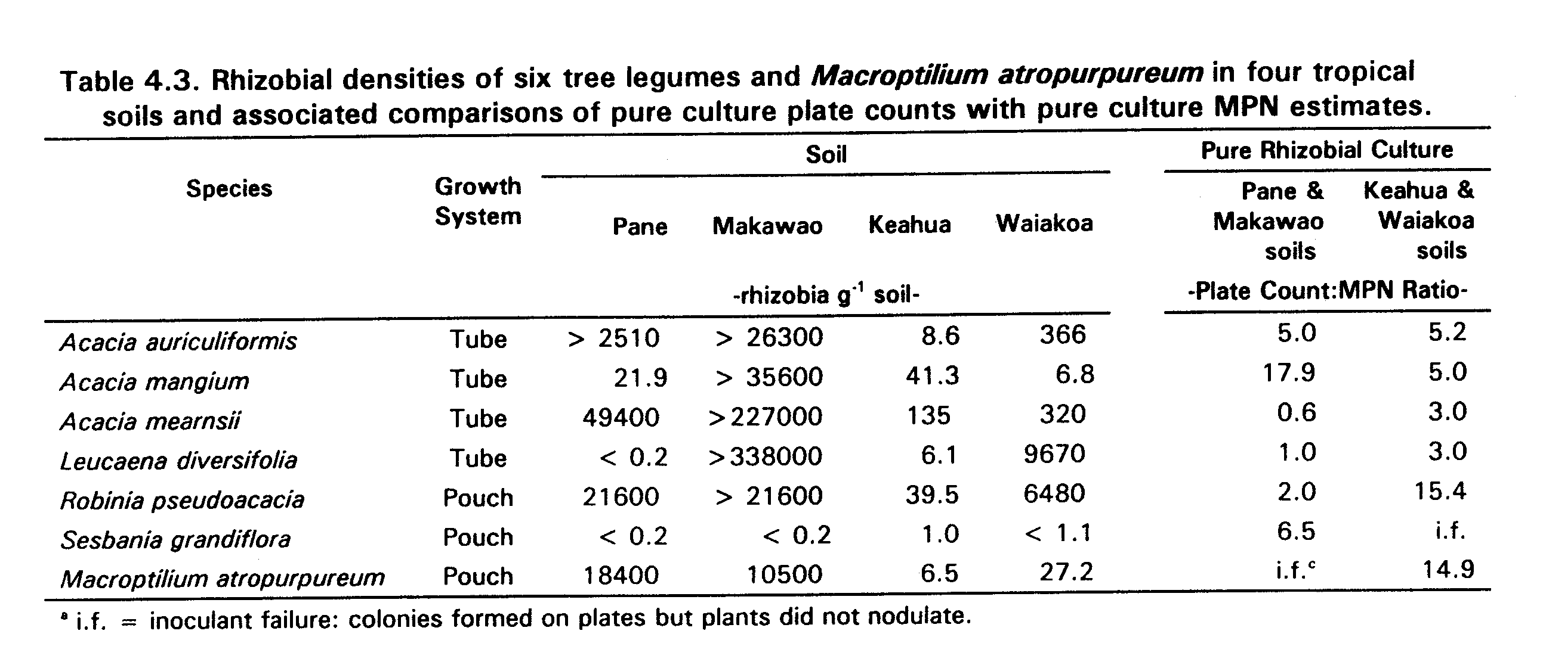

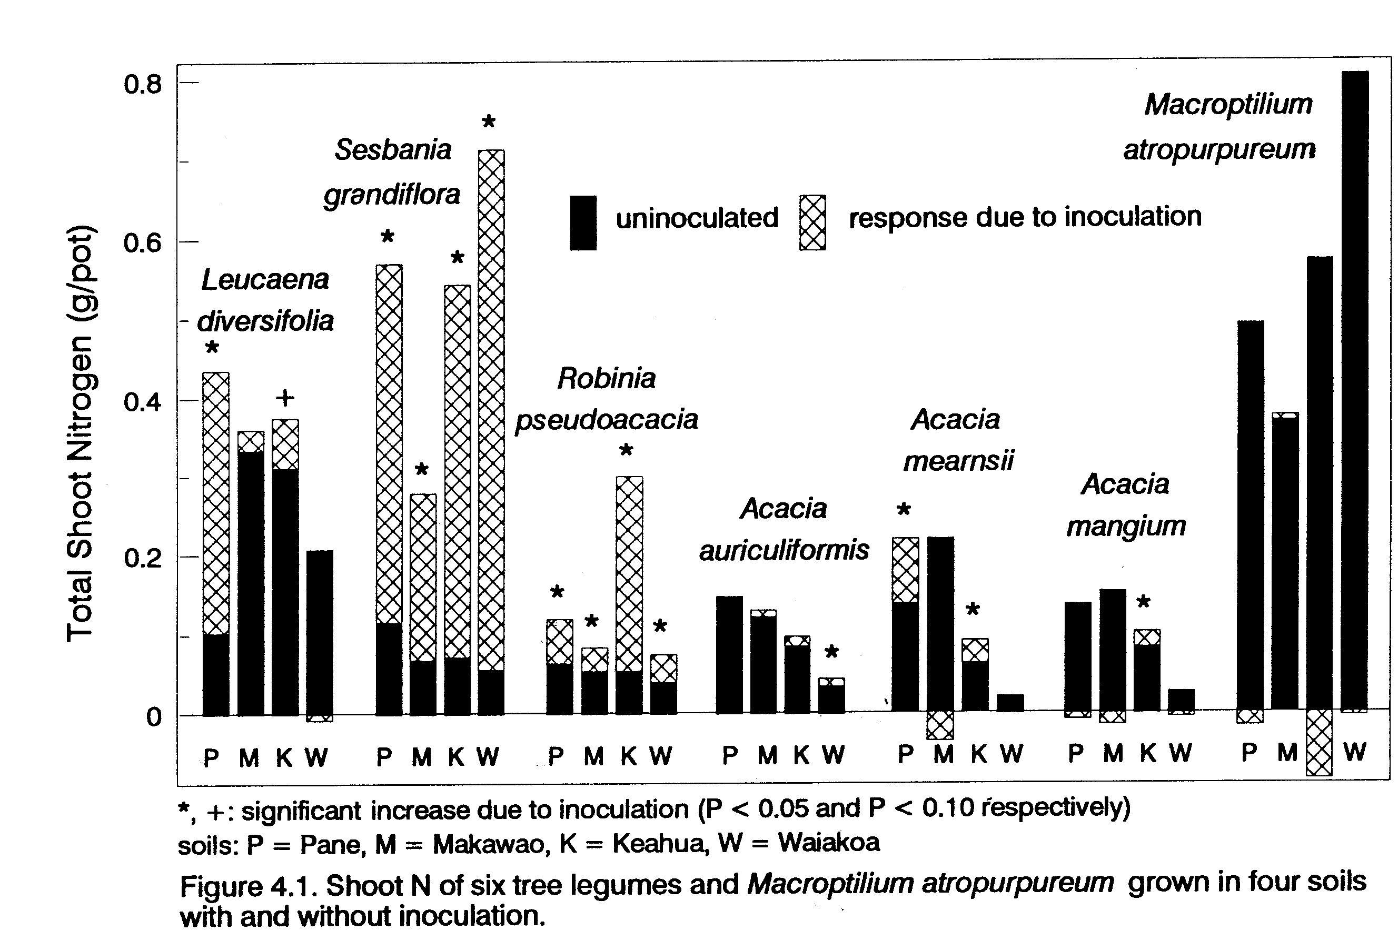
Chapter 5
Thesis Conclusion
Despite the passage of over a century since BNF in trees was first studied (Allen and Allen, 1981), knowledge of rhizobial relationships among tree species remains far behind that of grain and forage legumes. This thesis has added to the body of knowledge by taking techniques and approaches developed with grain and forage legumes and applying them to trees. Specifically, rhizobial effectiveness groups were determined for
a group of important tree legumes and this knowledge used in conjunction with measures of the density of indigenous rhizobial populations to determine the relationship between rhizobial density and response to inoculation.
Some of the contributions from this thesis are demonstration that reasonably accurate MPN estimates can be obtained with tree legumes, extension of the effectiveness group of Leucaena to include Calliandra calothyrsus, discovery that Robinia pseudoacacia and Acacia mearnsii are promiscuous for nodulation but specific for effectiveness, and confirmation that Acacia mangium is specific for both nodulation and effectiveness. Of practical importance, the data indicate that the approach developed for predicting yield response with grain and forage legumes can also be used with trees.
As a general conclusion, trees appear fundamentally similar to grain and forage legumes with respect to their rhizobial relations. As with grain and forage legumes, one rhizobial cell appears sufficient to cause nodule formation, a basic assumption of the MPN assay. Like other legumes, trees that nodulate effectively with Rhizobium fall into rather distinct effectiveness groups and species that nodulate effectively with Bradyrhizobium exhibit a range of specificity for both nodulation and effectiveness, without sharply delineated effectiveness groups. The minimal rhizobial density required for maximal BNF appears to be the same for trees and other legumes, in the order of 50 to 100 rhizobia g⁻¹ soil as determined by the MPN assay. As with other legumes, mineral N attenuates the response to inoculation as indicated by the improved fit of models that included an index of available mineral N.
Several aspects of tree-rhizobia relationships touched on in this thesis warrant further investigation. In Chapter 2, although fairly accurate MPN estimates were obtained with 11 of 14 species, other growth systems need to be evaluated for the remaining species. Open tubes and Leonard jars might be worth consideration.
There has been very little published information pertaining to strain selection for tree legumes. Evidence of rhizobial specificity in tree legumes (Chapter 3), especially for homologous strains, emphasizes the need to evaluate strains likely to have evolved in symbiosis with the species in question.
The response to inoculation of R. pseudoacacia and A. mearnsii in soils where rhizobial density was high emphasizes the need to develop tests for effectiveness to identify situations where species are likely to respond to inoculation despite high rhizobial densities. In this regard, an effectiveness test was conducted in association with the experiments presented in Chapter 4, but for several reasons it failed to identify tree-soil combinations where responses to inoculation occurred despite high rhizobial densities (Appendix C).
Uninoculated and inoculated treatments of A. mangium grew very poorly in Waiakoa soil despite a dramatic response to mineral N (Table 4.4). The fact that Waiakoa soil had the lowest available soil N as measured by the N mineralization test, and that inoculation increased yield of other tree species suggest that A. mangium has a higher requirement for starter N than species such as S. grandiflora. This and evidence that fast-growing species differ in their ability to fix N₂ in the presence of different levels of mineral N (George and Singleton, 1989) suggests that further work on relationships between N₂ fixation and mineral N might be fruitful, especially for species grown in association with food crops.

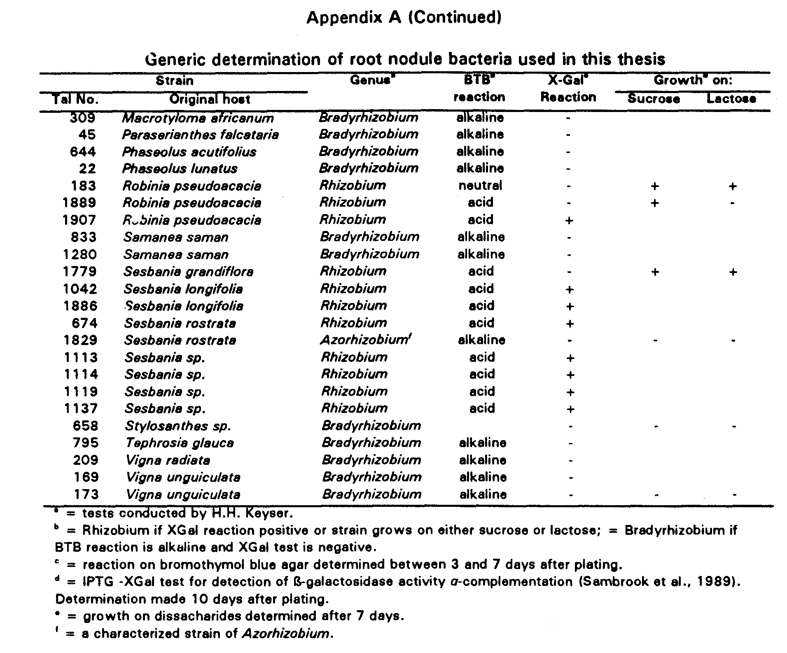
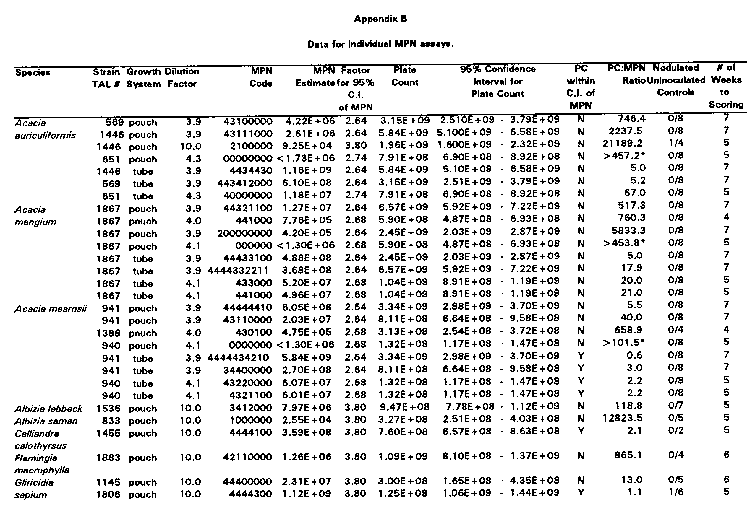

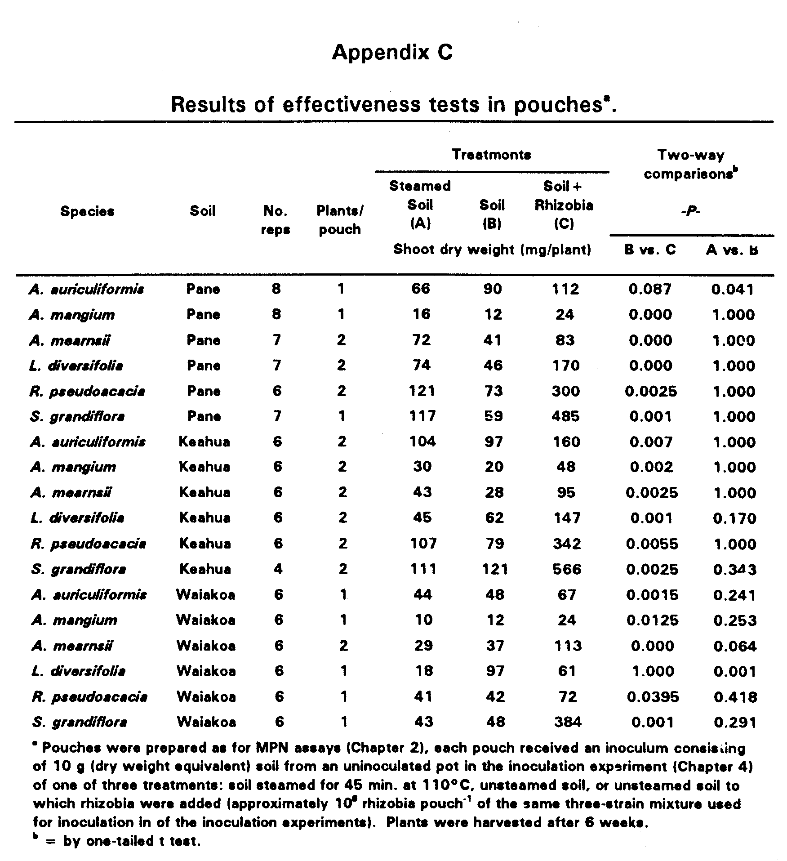
Literature Cited

Abdel Magid, H.M., P.W. Singleton, and J.W. Tavares. 1988. Sesbania-Rhizobium specificity and nitrogen fixation. Desert Plants 9(2):45-47.

Akkasaeng, R., P.C. Whiteman, and R.A. Date. 1986. Rhizobium requirements for two accessions of Gliricidia maculata. Tropical Grasslands 20(1):26-29.

Allen, O.N., and E.K. Allen. 1939. Root nodule bacteria of some tropical leguminous plants: II. Cross-inoculation tests within the cowpea group. Soil Sci. 47(1):63-76.

Allen, O.N. and E.K. Allen. 1981. The Leguminosae: a source book of characteristics, uses, and nodulation. The University of Wisconsin Press, Madison.

Barnet, Y.M., P.C. Catt, and D.H. Hearne. 1985. Biological nitrogen fixation and root-nodule bacteria (Rhizobium sp. and Bradyrhizobium sp.) in two rehabilitating sand dune areas planted with Acacia spp. Aust. J. Bot. 33:595-610.

Boonkerd, N. and R.W. Weaver. 1982. Cowpea rhizobia: comparison of plant infection and plate counts. Soil Biol. Biochem. 14:305-307.

Brewbaker, J.L., R. Van Den Beldt, and K. MacDicken. 1982. Nitrogen-fixing tree resources: potentials and limitations, p. 413-425. In P.H. Graham and S.C. Harris (ed.), Biological nitrogen fixation technology for tropical agriculture. CIAT, Cali, Colombia.

Brockweli, J. 1963. Accuracy of a plant-infection technique for counting populations of Rhizobium trifolii. Appl. Microbiol. 2:377-383.

Brockwell, J. 1980. Experiments with crop and pasture legumes-principles and practice, p. 417-488. In F.J. Bergersen (ed.) Methods for evaluating biological nitrogen fixation. John Wiley & Sons Ltd., Chichester.

Brockwell, J. 1982. Plant-infection counts of rhizobia in soil, p. 41-58. In J.M. Vincent (ed.) Nitrogen fixation in legumes. Academic Press, Sydney.
Brockwell, J., A. Diatloff, A. Grassia, and A. C. Robinson. 1975. Use of wild soybean (Glycine ussuriensis Regal and Maack) 3s a test plant in dilution-nodulation frequency tests for counting Rhizobium japonicum. Soil Biol. Biochem. 7:305-311.

Brockwell, J., R.A. Holliday, and A. Pilka. 1988. Evaluation of the symbiotic nitrogen-fixing potental of soils by direct microbiological means. Plant and Soil 108:163-170.

Burton, J.C. 1952. Host specificities among certain plants in the cowpea cross-inoculation group. Soil Sci. Soc. Am. Proc. 16:197-161.

Burton, J.C. 1977. Associations of some uncommon
leguminous plants with various rhizobia, p. 381-384. In
J.M. Vincent, A.S. Whitney, and J. Bose (ed.) Exploiting
the legume-Rhizobium symbiosis in tropical agriculture.
College of tropical agriculture miscellaneous publication
145, Department of Agronomy and Soil Science, University
of Hawaii.

Burton, J.C. 1979. Rhizobium species, p. 29-58. In
Microbial technology, 2nd ed., Vol. I, Academic Press.

Cochran, W.G. 1950. Estimation of bacterial densities by means of the "most probable number". Biometrics 6:105-116.

Crow, V.L., Jarvis, B.D.W., and R.M. Greenwood. 1981. Deoxyribonucleic acid homologies among acid-producing strains of Rhizobium. Int. J. Syst. Bacteriology 31:152172.

Date, R.A. 1977. Inoculation of tropical pasture legumes, p. 293-311. In J.M. Vincent, A.S. Whitney, and J.Bose (ed.) Exploiting the legume-Rhizobium symbiosis in tropical agriculture. College of Tropical Agriculture Miscellaneous Publication 145 Dept. of Agronomy and Soil Science, University of Hawaii.

Date, R.A. 1982. Assessment of the rhizobial status of the soil, p. 85-94. In J.M. Vincent (ed.), Nitrogen fixation in legumes. Academic Press, Sydney, Australia.

Date, R. A. 1991. Nitrogen fixation in Desmanthus: strain specificity of Rhizobium and responses to inoculation in acidic and alkaline soil. Tropical Grasslands 2547-2555.
Date, R.A. and J. Halliday. 1980. Relationships between Rhizobium and tropical forage legumes, p. 597-601. In R.J. Summerfield and A.H. Bunting (ed.) Advances in legume science, Royal Botanic Gardens, Kew.

Date, R.A., and D.O. Norris. 1979. Rhizobium screening of Stylosanthes species for effecitiveness in nitrogen fixation. Aust. J. Agric. Res. 30:85-104.

Davis, P.E. 1982. Desmanthus virgatus as a test plant for dilution-frequency infection tests using Leucaena leucocephala rhizobia. Soil Biol. Biochem. 14:313-314.

Department of Land and Natural Resources. 1982. Median rainfall. Circular CPS, Department of Natural Resources, Division of Water and Land Development, Honolulu, Hawaii.

Dommergues, Y.R. 1987. The role of biological nitrogen fixation in agroforestry, p. 245-271. In H.A. Steppler and P.K.R. Nair (ed.), Agroforestry, a decade of development. ICRAF, Nairobi, Kenya.

Dreyfus, B.L., H.G. Diem, J. Freire, S.O. Keya, and Y.R. Dommergues. 1987. Nitrogen fixation in tropical agriculture and forestry, p. 9-50. In E.J. DaSilva, Y.R. Dommergues, E.J. Nyns, and C. Ratledge (ed.) Microbial technology in the developing world. Oxford University Press, Oxford.

Dreyfus, E.L., and Y.R. Dommergues. 1981. Nodulation of Acacia species by fast- and slow-growing tropical strains of Rhizobium. Applied and Env. Microbiol. 41(1):97-99.

Duhoux, E., and Y. Dommergues. 1985. The use of nitrogen fixing trees in forest and soil restoration in the tropics, p. 384-400. In H. Ssali and S.O. Keya (ed.), Biological nitrogen fixation in Africa: proceedings of the first conference of the African association for biological nitrogen fixation. Matianum Press Consultants, Nairobi.

Galiana, A., J. Chaumont, H.G. Diem, and Y.R. Dommergues. 1990. Nitrogen-fixing potential of Acacia mangium and Acacia auriculiformis seedlings inoculated with Bradyrhizobium and Rhizobium spp. Biol. Fertil. Soils. 9:261-267.
George, T., and P.W. Singleton. 1989. Nodulation, N2 fixation and N assimilation during early growth by four tree legumes att different levels of mineral N supply. 12th North American Symbiotic Nitrogen Fixation Conference Proceedings. Ames Iowa. p. 120.

Gibson, A.H. 1980. Methods for legumes in glasshouses and controlled environment cabinets, p. 139-184. In F.J. Bergersen (ed.) Methods for evaluating biological nitrogen fixation. John Wiley & Sons Ltd., Chichester.

Gibson, A.H., B.L. Dreyfus, and Y.R. Dommergues. 1982. Nitrogen fixation by legumes in the tropics, p. 37-73. In Y.R. Dommergues and H.G. Diem (ed.) Microbiology of tropical soils and plant productivity. Martinus Nijhoff/Dr. W. Junk Publishers, The Hague.

Graham, P.H. and D.H. Hubbell. 1975. Legume Rhizobium relationships in tropical agriculture, p. 9-21. In E.C. Doll and G.O. Mott (ed.), Tropical forages in livestock production systems. ASA Special Publication No. 24.

Halliday, J., and P. Somasegaran. 1983. Nodulation, nitrogen fixation, and Rhizobium strain affinities in the genus Leucaena, p. 27-32. In Leucaena Research in the Asian Pacific Region, Proceedings of a workshop held in Singapore, 23-26 November, 1982, IDRC, Ottawa.

Jenkins, M.B., R.A. Virginia, and W.M. Jarrell. 1987. Rhizobial ecology of the woody legume mesquite (Prosopis glandulosa) in the sonoran desert. Appl. Environ. Microbiol. 53(1):36-40.

Johnson, M.D., and O.N. Allen. 1952. Nodulation studies with special reference to strains isolated from Sesbania species. Antonie van Leeuwenhjoek J. Microbiol. Serol. 18(1):1-12.

Kang, B.T., G.F. Wilson, and T.L. Lawson. 1984. Alley cropping, a stable alternative to shifting cultivation. International Institute of Tropical Agriculture, Ibadan, Nigeria.

Keeney, D.R. 1982. Nitrogen-availability indices. Agronomy 9:711-733.

Keyser, H.H., and P.B. Cregan. 1987. Nodulation and competition for modulation of selected soybean genotypes among Bradyrhizobium japonicum serogroup 123 isolates. Appl. Environ. Microbiol. 53:2631-2635.
Ndoye, I.; K.Tomekpe, B. Dreyfus, and Y.R. Dommergues. 1990. Sesbania and Rhizobium symbiosis: nodulation and nitrogen fixation. in Macklin, B., and D.O. Evans (eds.) Perennial Sesbania species in agroforestry systems. NFTA, Waimanalo, Hawaii.

NifTAL and FAO. 1984. Legume inoculants and their use. Rome.

Peoples, M.B., A.W. Faizah, B. Rerkasem, and D.F. Herridge. 1989. Methods for evaluating nitrogen fixation by nodulated legumes in the field. ACIAR, Canberra.

Sadowsky, M.J., R.E Tullv, P.B. Cregan, and H.H. Keyser. 1987. Genetic diversity in Bradyrhizobium japonicum serogroup 123 and its relation to genotype-specific nodulation of soybean. Appl. and Environ. Microbiol. 53(11):2624-2630.

Sambrook, J., E.F. Fritsch, and T. Maniatis. 1989. Molecular cloning: a laboratory manual. Second Edition, Vol. 1. Cold Spring Harbor Laboratory Press, Cold Spring Harbor, N.Y.

Sanginga, N., K. Mulongoy, and A. Ayanaba. 1987. Evaluation of indigenous strains of Rhizobium for Leucaena leucocephala (Lam.) De Wit in Nigeria conditions, p. 416436. In Les arbres fixateurs d'Azote: l'amelioration biologique de la fertilite des sols. Ed. ORSTOM. ORSTOM, Paris.

Sanginga, N., K. Mulongoy, A. Ayanaba. 1985. Effect of inoculation and mineral nutrients on nodulation and growth of Leucaena leucocephala, p. 419-427. In H. Ssali and S.O. Keya (ed.) Biological nitrogen fixation in Africa. Proceedings of the African Association for Biological Nitrogen Fixation, Matianum press consultants, Nairobi.

SAS Institute. 1986. SAS users' guide: Statistics. SAS Institute Inc., Cary, N.C.

Scott, J.M. and F.E. Porter. 1986. An analysis of the accuracy of a plant infection technique for counting rhizobia. Soil Biol. Biochem. 18:355-362.

Singer, M.J., and D.N. Munns. 1987. Soils: an introduction. Macmillan Publishing Company, N.Y.
Singleton, P.W. and J.W. Tavares. 1986. Inoculation response of legumes in relation to the number and effectiveness of indigenous rhizobium populations. Appl. and Env. Microbiol. 51(5):1013-1018.

Singleton, P.W., B.B. Bohlool, and P.L. Nakao. 1991a. Legume response to rhizobial inoculation in the tropics: myths and realities. In R.Lal and P. Sanchez (ed.), Myths and science of soils in the tropics. ASA special publication, in press. ASA-SSSA-CSSA, Madison, Wis.

Singleton, P.W., P.L. bloomer, J.E. Thies, P.L. Nakao, and B.B. Bohlool. 1991b. Protocols for field and greenhouse experimentation in legume BNF: Standardized network trials to develop models describing the ecology and performance of the rhizobium-legume symbiosis. University of Hawaii NifTAL Project, Paia.

Somasegaran, P., and H.J. Hoben. 1985. Methods in legume-Rhizobium technology. University of Hawaii NiFTAL Project, Paia.

Somasegaran, P., H.H. Keyser, and J.P. Roskoski. 1989. Rhizobial requirement and inoculation response of Gliricidia sepium (Jacq.) Walp. 12th North American Symbiotic Nitrogen Fixation Conference Proceedings. Ames Iowa. p. 77.

Thies, J.E., P.W. Singleton, and B.B. Bohlool. 1991a. Influence of the size of indigenous rhizobial populations on establishment and symbiotic performance of introduced rhizobia on field-grown legumes. Appl. and Env. Microbiol. 57(1):19-28.

Thies, J.E., P.W. Singleton, and B.B. Bohlool. 1991b. Modeling symbiotic performance of introduced rhizobia in the field by use of indices of indigenous population size and nitrogen status of the soil. Appl. and Env. Microbiol. 57(1):29-37.

Thies, J.E., B.B. Bohlool, and P.W. Singleton. 1991c. Subgroups of the cowpea miscellany: symbiotic specificity within Bradyrhizobium spp. for Vigna unguiculata, Phaseolus lunatus, Arachis hypogaea, and Macroptilium atropurpureum. Appl. Environ. Microbiol. 57(5):1540-1545.

Thompson, J.A., and J.M. Vincent. 1967. Methods of detection and estimation of rhizobia in soil. Plant and Soil 26(1):72-84.
Toomsan, B., O.P. Rupela, S. Mittal, P.J. Dart, and K.W. Clark. 1984. Counting cicer-Rhizobium using a plant infection technique. Soil Biol. Biochem. 16(5):503-507.

Trinick, 1982. Host-Rhizobium Associations, p. 111-122. In J.M. Vincent (ed.) Nitrogen fixation in legumes. Academic Press, Sydney.

Tuzimura, K., and I. Watanabe. 1961. Estimation of number of root-nodule bacteria by a nodulation-dilution frequency method. Soil Science and Plant Nut. 7(2):61-65.

Vincent, J.M. 1970. A manual for the practical study of, root-nodule bacteria. IBP Handbook No. 15. Burgess and s^n (Abingdon) LTD, Berkshire.

Virginia, R.A., M.B. Jenkins, and W.M. Jarrell. 1986. Depth of root symbiont occurrence in soil. Biol. Fertility Soils 2:127-130.

Weaver, R.W., and L.R. Frederick. 1972. A new technique for most-probable-number counts of Rhizobia. Plant and Soil 36:219-222.

Wilkinson, L. 1990. SYSTAT: The system for statistics. Evanston, IL, SYSTAT, Inc.

Wilson, J.K. 1944. Over five hundred reasons for abandoning the cross-inoculation groups of the legumes. w Soil Sci. 58:61-69.

Woomer, P., P.W. Singleton, and B.B. Bohlool. 1988a. Ecological indicators of native rhizobia in tropical soils. Applied and Env. Microbiol. 54(5):1112-1116.

Woomer, P., P.W. Singleton, and B.B. Bohlool. 1988b. Reliability of the most-probable-number technique for enumerating rhizobia in tropical soils. Applied and Env. Microbiol. 54(6):1494-1497.

Woomer, P., J. Bennett, and R. Yost. 1990. Overcoming the inflexibility of most-probable-number procedures. Agron. J. 82:349-353.

